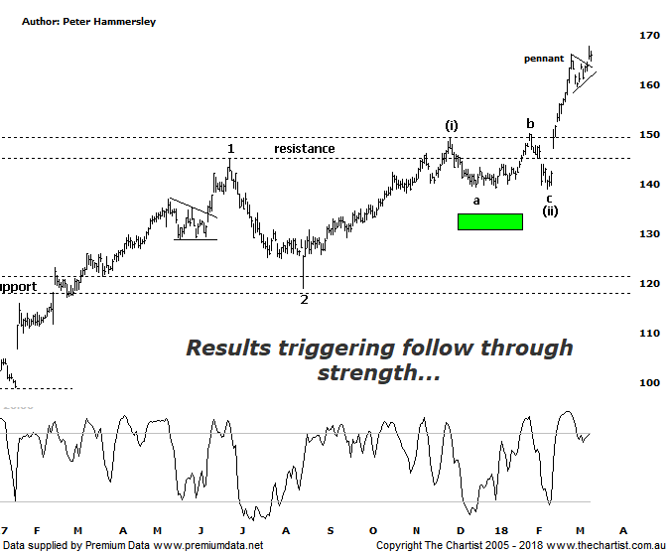

Bottom Line
13/3:
Daily Trend: Up
Weekly Trend: Up
Monthly Trend: Up
Support levels: $149.30 - $145.00
Resistance levels: N/A
Video Analysis
Watch Video Analysis Here
Technical Discussion
CSL conducts research of biopharmaceutical products. Following positive results, it continues into the development and manufacturing stages before distributing the product. It operates in three segments; CSL Behring, Intellectual Property licensing and Other Human Health. The latter consists of CSL Bioplasma and CSL Biotherapies. Recently the company has acquired the Novartis flu vaccine business now making it the world’s second largest manufacturer. Whilst this may generate near term head-winds, longer term it’s expected to increase its profile significantly and turn a loss maker into a globally competitive business. Net profit for the first half increased by 35% to US$1.1 billion. Revenue increased, in part due to strong sales of its flu vaccine which soared by 43%. A. Interim dividend of US$0.79 will be paid. Analyst consensus is currently “Buy”. The dividend yield is 1.1%.
Reasons to remain bullish (short term weakness feasible).
→ Earnings released today were above consensus.
→ Volume growth expected for immunoglobulin/albumin.
→ Competitor weakness has been advantageous.
→ Exceptional earnings growth anticipated.
→ The recent launch of Haegarda could be a potential catalyst for the company.
→ Acquiring 80% of a Chinese plasma fractionator which should provide a foothold into China.
→ Benefiting from the plasma supply bottlenecks as CSL can increase supply.
→ New product launches add to near-term growth prospects.
→ Ongoing acquisitions offer strong gains in synergy.
Results had just been announced on the day of our last review with the market giving the thumbs up with price gapping higher and closing on the highs of the session. We’ve seen strong reactions to results both positive and negative over the past few weeks although a lot of the time that reaction has been short-lived with no follow-through. Not so here, with CSL continuing to trend higher in a strong impulsive manner through all-time highs and into blue sky territory. Not surprisingly the stock is looking overbought due to the potency of the recent leg higher on both the daily and weekly timeframes. In fact, bearish divergence is also showing on both charts although it’s yet to trigger on either meaning it’s something to watch only as opposed to advocating an immediate leg South. If the divergence triggers on the daily chart it’s also likely to on the weekly which would imply a decent retracement is going to unfold, albeit it would be deemed as being healthy in the bigger scheme of things. Our wave count continues to prove itself with intermediate degree wave-(iii) being exceptionally strong which is only to be expected at this stage of the trend. Normally, wave-(iii) will be the strongest of all the impulsive waves which is even more significant here as price is also heading higher within larger degree wave-3. Concentrating on the larger degree patterns, this portends a continuation up to the 1.618 projection of wave-1 which provides a target around $205.00 which is still a significant percentage gain from current levels. It would now take a push beneath the recent pivot low at $140.45 to move back to a neutral stance although a continuation down through $119.00 to suggest a more significant top is in place. Neither scenario is looking likely at this stage. The risk remains to be upside, albeit the divergence needs watching.
Trading Strategy
Price has just broken higher out of a small pennant or micro triangle but now appears to be coming back to retest the breakout area. This is perfectly normal and could even provide a buying opportunity should it transpire. Look for the upper trend line of the pennant to be tagged and rejected before initiating long positions. Aggressive traders could place the protective stop just beneath the minor pivot low at $159.58 although if you want to allow a little more wiggle room then just beneath the minor line of support at $147.00 will suffice. I can’t make a formal recommendation due to the bearish divergence which will be a stumbling block should it trigger on both timeframes. Medium to longer term though there is still everything to like.

