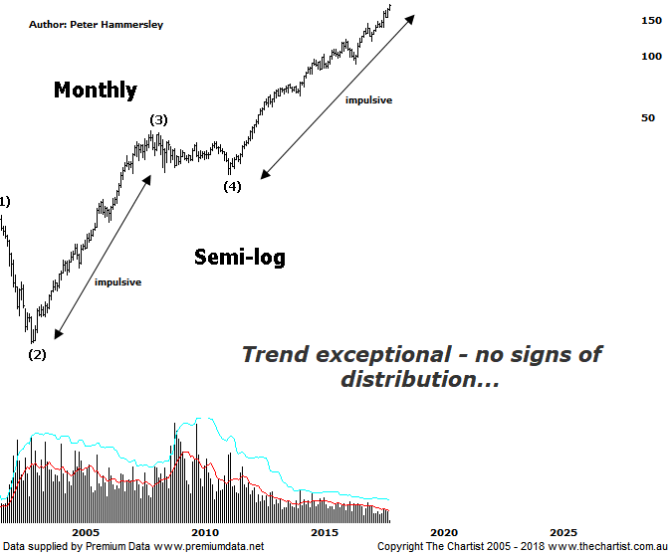

Bottom Line
16/5:
Daily Trend: Up
Weekly Trend: Up
Monthly Trend: Up
Support levels: $150.15 - $149.30 / $138.92
Resistance levels: N/A
Video Analysis
Watch Video Analysis Here
Technical Discussion
CSL conducts research of biopharmaceutical products. Following positive results, it continues into the development and manufacturing stages before distributing the product. It operates in three segments; CSL Behring, Intellectual Property licensing and Other Human Health. The latter consists of CSL Bioplasma and CSL Biotherapies. Recently the company has acquired the Novartis flu vaccine business now making it the world’s second largest manufacturer. Whilst this may generate near term head-winds, longer term it’s expected to increase its profile significantly and turn a loss maker into a globally competitive business. For the six months ending the 31st of December 2017 revenues increased 13% to $4.15B. Net income increased 35% to $1.09B. Revenues highlight the CSL Behring section increase of 10% to $3.36B, the Seqirus section increase of 28% to $791.1M, the United States section increase of 21% to $1.97B and the Germany section increase of 15% to $405.9M. Analyst consensus is currently “Buy”. The dividend yield is 1.0%.
Reasons to remain bullish (short term weakness feasible).
→ The U.S FDA has approved Hizentra to treat neurological disease.
→ Sales growth continues to be robust.
→ A maiden profit from Seqirus could resulting in FY18 guidance being exceeded.
→ Volume growth expected for immunoglobulin/albumin.
→ Competitor weakness has been advantageous.
→ Exceptional earnings growth anticipated.
→ The recent launch of Haegarda could be a potential catalyst for the company.
→ Acquiring 80% of a Chinese plasma fractionator which should provide a foothold into China.
→ Ongoing acquisitions offer strong gains in synergy.
Strangely enough, as strong as this trend has been over the years the wave count on this monthly chart does lack clarity. For the most part this is due to the potency of the trend since inception going all the way back to 1994 which has been nothing short of exceptional. That said, our labelling remains firmly intact although wave-(5) continues to extend which shouldn’t really come as a shock considering the on-going strength that continues to show. Regarding the wave count we’ll continue to run with the smaller degree patterns which continue to prove themselves whilst also offering plenty of upside potential. Without going into too much detail, the daily chart (which we looked at a week ago) shows a series of first and second legs which is an exceptionally bullish labelling of price. Back to this chart shows a possible headwind at $192.74 although it’s by no means a high probability reversal zone. However, it is an area to keep close eye on should a few sellers entered the fray. From a technical stance, it would be difficult to find a more bullish looking chart. Higher highs and higher lows continue to form, with buyers waiting in the wings to jump onto any short-term weakness. There’s no reason why this characteristic shouldn’t continue well into the future. There’s always a possibility with a stock like CSL that negative news regarding a drug puts a dent into the share price although these have been few and far between over the years. Strength always returns which highlights how well the company is run. Brokers continue to remain enamoured with the stock with “buy” recommendations being the main theme. The company appears well positioned to deliver strong earnings growth in 2018-2019.
Trading Strategy
“…there is little to be lost by jumping on following a probe above today’s high. The protective stop can be placed just beneath the recent pivot low at $154.78 which allows plenty of wiggle room…” We are now holding long positions although it’s too early to tighten the protective stop despite strength continuing over the past week. However, if this trait continues we’ll be reducing the risk which is already low. If you aren’t already involved it’s best to continue to stand aside until another low risk entry presents itself. Should our analysis be correct the strongest part of a larger trend should be in motion, offering exceptional upside potential over the coming months.

