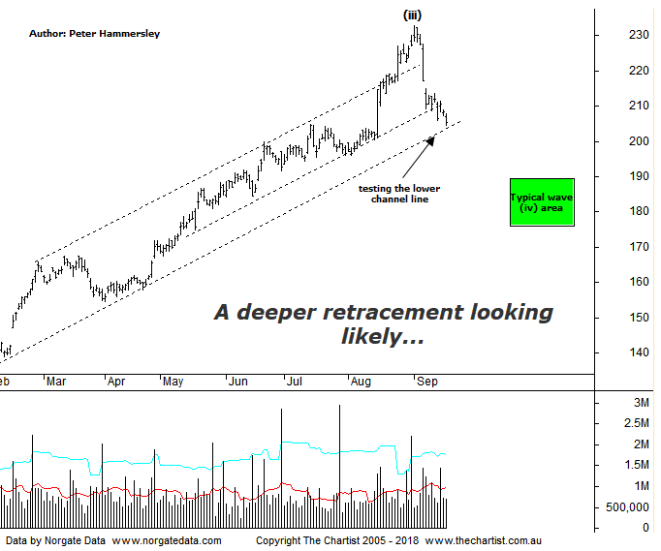

Bottom Line
18/9:
Daily Trend: Down
Weekly Trend: Up
Monthly Trend: Up
Support levels: $196.09 / $191.64 / $150.15 - $149.30
Resistance levels: $232.69
Video Analysis
Watch Video Analysis Here
Technical Discussion
CSL conducts research of biopharmaceutical products. Following positive results, it continues into the development and manufacturing stages before distributing the product. It operates in three segments; CSL Behring, Intellectual Property licensing and Other Human Health. The latter consists of CSL Bioplasma and CSL Biotherapies. Recently the company has acquired the Novartis flu vaccine business now making it the world’s second largest manufacturer. Whilst this may generate near term head-winds, longer term it’s expected to increase its profile significantly and turn a loss maker into a globally competitive business. For the year ending the 30th of June 2018 revenues increased 14% to $7.92B. Net income increased 29% to $1.73B. Revenues highlight the Behring section increase of 15% to $6.7B, the Seqirus section increase of 21% to $950.6M, the United States section increase of 24% to $3.52B and the United Kingdom section increase of 70% to $362.6M. Dividend per share increased from $1.35 to $1.69. Analyst consensus is currently “Hold”. The dividend yield is 1.1%.
Reasons to remain bullish (short term weakness feasible).
→ Well positioned to meet immunoglobulin demand.
→ The supply chain investment should be supportive to continued volume growth.
→ Heavy investment in plasma collection centres which should grow market share.
→ The U.S FDA has approved Hizentra to treat neurological disease.
→ Volume growth expected for immunoglobulin/albumin.
→ Competitor weakness has been advantageous.
→ The recent launch of Haegarda could be a potential catalyst for the company.
→ Acquiring 80% of a Chinese plasma fractionator which should provide a foothold into China.
→ Ongoing acquisitions offer strong gains in synergy.
There’s been no reason to be anything other than bullish on CSL over previous months with the uptrend continuing to chug along very nicely. However, healthcare has been under some pressure recently and CSL has started to see some profit-taking kick in. This isn’t major reason for concern although there is still downside potential over the coming weeks meaning some caution is required. Price was hovering around the upper boundary of the rising channel during the last review although clear rejection has proved to be the way forward. Price is now hovering around the lower trend line of the larger channel meaning if we are to see some demand return now is as good a time as any for it to show. Recent weakness is enough for us to lock in wave-(iii) which brings the target area as shown either the side of $180.00 to the fore. Quite often wave-(iv) will retrace between 38.2% - 50% of the leg higher within wave-(iii) which is what we are looking for here. As long as a corrective pattern takes price down into that area the longer-term bullish case remains firmly on track. On the flipside, should buyers step up immediately around the lower boundary of the channel, resulting in a push up through the recent pivot high at $232.69 then we are incorrect regarding the deeper retracement. This would be a very bullish turn of events although it’s not our highest expectation to break into blue sky territory without first seeing a longer and deeper retracement.
Trading Strategy
Last month we spoke about the importance of giving the trade room to breathe, to allow a small profit the potential to turn into a large one. However, when the smaller degree patterns take a turn for the worse (as they did here) it’s also just as important to protect open profits by reducing risk. This is something we acted on at the beginning of this month with the end result being a profit of just over 20%. It goes without saying that we’d have preferred to stay on the trend longer, but the correct decision was made. As it turns out, if we’d continued to hold then those profits would have been significantly lower as price continues to head south. We’ll continue to stand aside from this one and let the current correction run its course although we’ll be keen to jump on the longer-term trend again when the smaller degree patterns permit.

