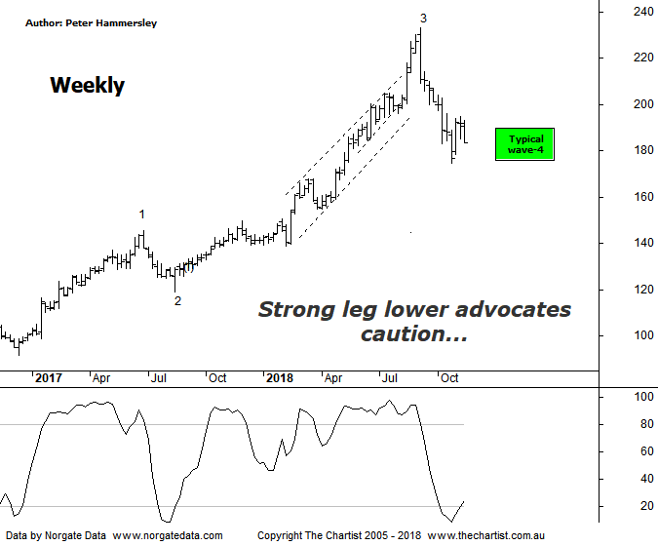

Bottom Line
14/11:
Daily Trend: Down
Weekly Trend: Down
Monthly Trend: Neutral
Support levels: $150.15 - $149.30
Resistance levels: $232.69
Video Analysis
Watch Video Analysis Here
Technical Discussion
CSL conducts research of biopharmaceutical products. Following positive results, it continues into the development and manufacturing stages before distributing the product. It operates in three segments; CSL Behring, Intellectual Property licensing and Other Human Health. The latter consists of CSL Bioplasma and CSL Biotherapies. Recently the company has acquired the Novartis flu vaccine business now making it the world’s second largest manufacturer. Whilst this may generate near term head-winds, longer term it’s expected to increase its profile significantly and turn a loss maker into a globally competitive business. For the year ending the 30th of June 2018 revenues increased 14% to $7.92B. Net income increased 29% to $1.73B. Revenues highlight the Behring section increase of 15% to $6.7B, the Seqirus section increase of 21% to $950.6M, the United States section increase of 24% to $3.52B and the United Kingdom section increase of 70% to $362.6M. Dividend per share increased from $1.35 to $1.69. Analyst consensus is currently “Buy”. The dividend yield is 1.3%.
Reasons to remain bullish (short term weakness feasible).
→ Positioned to meet immunoglobulin demand.
→ The supply chain investment should be supportive to continued volume growth.
→ Heavy investment in plasma collection centres which should grow market share.
→ The U.S FDA has approved Hizentra to treat neurological disease.
→ Volume growth expected for immunoglobulin/albumin.
→ Competitor weakness has been advantageous.
→ The recent launch of Haegarda could be a potential catalyst for the company.
→ Acquiring 80% of a Chinese plasma fractionator which should provide a foothold into China.
→ Ongoing acquisitions offer strong gains in synergy.
Funnily enough some brokers have become a little more bullish on CSL over the past few weeks, whilst it’s been heading down with some intent. Needless to say, analysts are probably suggesting it is better value at these lower levels although of course this isn’t necessarily the case. In fact, from our perspective there’s no reason to be buying around current levels, even though there’s a case for seeing a decent bounce. Last time we suggested that a push down through the initial target just beneath $180.00 portended a continuation down to the next target zone sitting between $162.00 - $145.65. This is still feasible although on this weekly timeframe it would be less than ideal from an Elliott perspective. The reason being, from the significant lows made in December 2016 we’ve only seen 3-waves higher as opposed to the expected 5-waves. In other words, the current retracement should be within a larger degree wave-4. Should this be the way forward then buyers need to step up immediately as price will normally head down to the 38.2% - 50% retracement zone of the whole leg higher within wave-3 which is pretty much where CSL currently sits. There’s no room for lower prices, with a push beneath the recent pivot low at $174.69 being the final nail in the Coffin regarding avoiding a deeper retracement. We must also be cognizant of the fact that the retracement which commenced in early September has been strong and impulsive in nature which is always reason to be cautious. The bottom line is, the patterns had deteriorated during our last review which is a trait that has continued.
Trading Strategy
The more bullish interpretation of the wave count needs to prove itself before getting involved meaning we’ll continue to sit this one out. We were fortunate to ride a decent portion of the leg higher up to the high made in September this year although it could be a while before a trend of that magnitude kicks in again. We still like the fundamentals of the company as well as its prospects moving forward but patience is going to be required over the coming weeks and probably months ahead.

