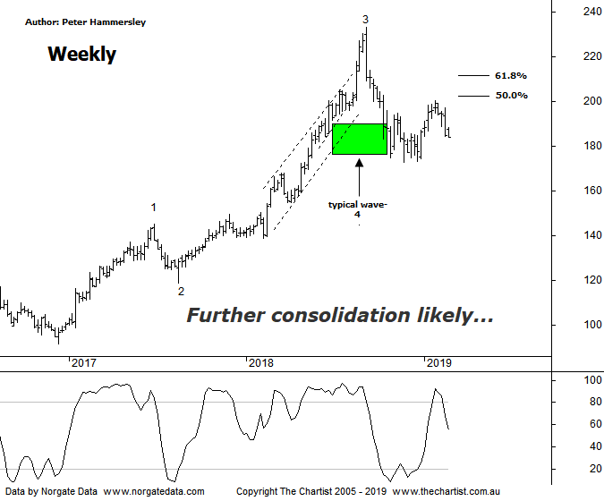

Bottom Line
19/2:
Daily Trend: Down
Weekly Trend: Down
Monthly Trend: Down
Support levels: $173.00 / $150.15 - $149.30
Resistance levels: $232.69
Video Analysis
Watch Video Analysis Here
Technical Discussion
CSL conducts research of biopharmaceutical products. Following positive results, it continues into the development and manufacturing stages before distributing the product. It operates in three segments; CSL Behring, Intellectual Property licensing and Other Human Health. The latter consists of CSL Bioplasma and CSL Biotherapies. Recently the company has acquired the Novartis flu vaccine business now making it the world’s second largest manufacturer. Whilst this may generate near term head-winds, longer term it’s expected to increase its profile significantly and turn a loss maker into a globally competitive business. For the six months ending the 31st of December 2018 revenues increased 9% to $4.51B. Net income increased 7% to $1.16B. Revenues highlight the CSL Behring section increase of 6% to $3.56B, the Seqirus section increase of 20% to $948.6M, the United States section increase of 18% to $2.33B and the United Kingdom section increase of 48% to $266.1M. Net income was partially offset by selling and marketing expenses which increased 19% to $422.8M. Analyst consensus is currently “Buy”. The dividend yield is 1.3%.
Reasons to remain bullish (short term weakness feasible).
→ Positioned to meet immunoglobulin demand. The supply chain investment should be supportive to continued volume growth.
→ Heavy investment in plasma collection centres which should grow market share.
→ The U.S FDA has approved Hizentra to treat neurological disease.
→ Volume growth expected for immunoglobulin/albumin.
→ Competitor weakness has been advantageous.
→ The recent launch of Haegarda could be a potential catalyst for the company.
→ Acquiring 80% of a Chinese plasma fractionator which should provide a foothold into China.
→ Ongoing acquisitions offer strong gains in synergy.
The headline pattern last time was a descending triangle, with price having just broken through the upper boundary in an impulsive fashion. This gave us confidence that price was going to head up toward the typical retracement zone. Although a rally has unfolded our target area wasn’t quite achieved. This does keep the door open for another leg higher although we must be cognizant of the reaction to results announced last Wednesday. Price that day initially gapped higher although once again there was no follow-through to the upside with sellers overpowering buyers during the session resulting in a close almost on the session’s lows. This is a trait that’s starting to show itself, with plenty of companies gapping higher following results only for strength to wane immediately - CPU is another that immediately comes to mind. Tonight we are going to flip back to the weekly chart which emphasises how strong the prior trend has been, especially from the late 2016 lows where price was sitting around $91.00. Regarding the wave count, nothing changes, with the ideal situation being that wave-4 is still unfolding. Normally price will head down to the 38.2% - 50% retracement zone of the whole leg higher within wave-3 which is a box that can be ticked. However, on the daily chart (not shown) it was an impulsive leg down toward that target area which should not complete the whole corrective pattern. In other words, it’s more than feasible to posture in this general region for several months to come to complete the countertrend movement. This does open the door for strength over the coming weeks although there is no indication that the strong longer-term uptrend is going to kick into gear from current levels. Bullish divergence is evident on the daily chart with price making a lower low whilst our oscillator has made a higher low. It’s yet to trigger, although should this be the way forward then a bounce is likely going to commence.
Trading Strategy
There are still plenty of stocks trending nicely, so we should concentrate on stocks showing strong relative strength or those showing good reversal patterns. CSL doesn’t fit the bill in either department. Even if the bullish divergence triggers, upside is likely going to be limited. If a larger flat pattern or triangle unfolds price could eventually head up toward $220 - $230 although it’s by no means set in stone. Either way, there is no formal recommendation this evening.

