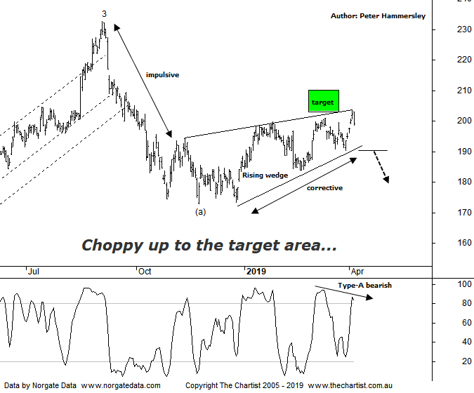

Bottom Line
4/4:
Daily Trend: Up
Weekly Trend: Up
Monthly Trend: Up
Support levels: $173.00 / $150.15 - $149.30
Resistance levels: $232.69
Video Analysis
Watch Video Analysis Here
Technical Discussion
CSL conducts research of biopharmaceutical products. Following positive results, it continues into the development and manufacturing stages before distributing the product. It operates in three segments; CSL Behring, Intellectual Property licensing and Other Human Health. The latter consists of CSL Bioplasma and CSL Biotherapies. Recently the company has acquired the Novartis flu vaccine business now making it the world’s second largest manufacturer. Whilst this may generate near term head-winds, longer term it’s expected to increase its profile significantly and turn a loss maker into a globally competitive business. For the six months ending the 31st of December 2018 revenues increased 9% to $4.51B. Net income increased 7% to $1.16B. Revenues highlight the CSL Behring section increase of 6% to $3.56B, the Seqirus section increase of 20% to $948.6M, the United States section increase of 18% to $2.33B and the United Kingdom section increase of 48% to $266.1M. Net income was partially offset by selling and marketing expenses which increased 19% to $422.8M. Analyst consensus is currently “Hold”. The dividend yield is 1.2%.
Reasons to remain bullish (short term weakness feasible).
→ Positioned to meet immunoglobulin demand. The supply chain investment should be → supportive to continued volume growth.
→ Heavy investment in plasma collection centres which should grow market share.
→ The U.S FDA has approved Hizentra to treat neurological disease.
→ Volume growth expected for immunoglobulin/albumin.
→ Competitor weakness has been advantageous.
→ The recent launch of Haegarda could be a potential catalyst for the company.
→ Acquiring 80% of a Chinese plasma fractionator which should provide a foothold into China.
→ Ongoing acquisitions offer strong gains in synergy.
Before we get into the smaller degree patterns it’s worth noting that bigger picture we continue to like what we see, with plenty of upside potential ahead over the coming years. However, during our last review we noted we were looking for a bounce only and not a resumption of the strong prior uptrend. The bounce zone has now been tagged which opens the door for another leg South either immediately or in a week or two’s time. The interesting development here has been the formation of the Rising wedge which is a pattern that’s been cropping up a lot on the charts recently. These are one of the strongest reversal patterns available, especially when they coincide with bearish divergence. Talking of which, divergence is evident on both the daily and weekly charts here, with price making a higher high whilst our oscillator has failed to confirm by making a lower high. It’s yet to trigger although another day or two like today and this will likely be the way forward. A push through the lower trend line of the wedge would likely cement a top as being in place and set the stage for the next leg lower. It would take a push above the 61.8% level at $209.90 to suggest a deeper retracement can be avoided. That said, even then we’d only be looking for a continuation up toward the high of wave-3 before the next leg lower unfolds. The slightly more bullish scenario would suggest some range bound price action over the coming months although there will be tradable moves along the way. We’ll take a look at the larger degree patterns during this evening’s video for clarity.
Trading Strategy
The Rising wedge does provide a shorting opportunity if you are that way inclined although the lower boundary would need to be overcome before initiating short positions. I’d be more inclined to put short setups forward if the broader market was looking weaker. This may transpire following today’s intraday weakness but it still needs to prove itself. If you are looking for the bigger buying opportunity it could be a while before an opportunity arises.

