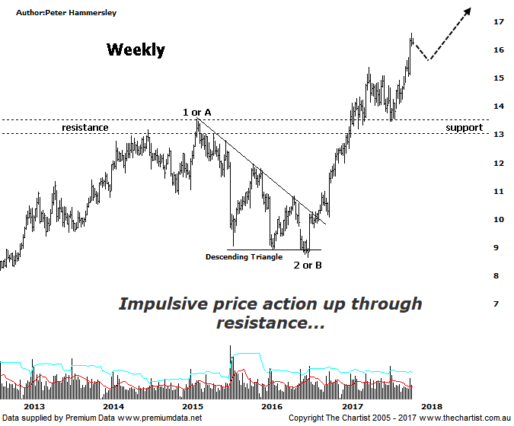

Bottom Line
27/11:
Daily Trend: Up
Weekly Trend: Up
Monthly Trend: Up
Support Levels: $13.46 - $13.17 / $12.01 / $11.22
Resistance Levels: N/A
Video Analysis
Watch video analysis here
Technical Discussion
Computershare (CPU) is engaged in the operation of investor services, plan services, communication services, business services, stakeholder relationship management services and technology services. Its sections include Asia, Australia and New Zealand, Canada, Continental Europe; United Kingdom, Channel Islands, Ireland & Africa, and the United States of America. The investor services operations include the provision of registry maintenance and related services. The plan services operations include the provision of administration and related services. The communication services operations include scanning and electronic delivery. The business services operations include the provision of bankruptcy and mortgage servicing activities. The stakeholder relationship management services group provides investor communication and management information services. Its technology services include the provision of software, specializing in share registry and financial services. For the year ending the 30th of June 2017 revenues increased 7% to $2.11B. Net income increased 69% to $266.4M. Revenues reveal an increase in demand for the Company's products and services due to advantageous market conditions. Broker consensus is “Sell”. The dividend yield is 2.2%.
Reasons to be bullish (downside risk short-term):
→ Recent results suggest momentum is continuing.
→ A $200m bi-back has been announced.
→ Profits should be boosted from the contract with UKAR in FY19.
→ Management continue to concentrate on cost reductions.
→ The increased dividend and reduced gearing highlights the cash generating model.
Strong earnings growth.
→ A healthy retracement is unfolding following a very strong uptrend.
The better patterns remain on the weekly chart, so we’ll continue to concentrate on the larger degree patterns. One thing is for sure, price was looking bullish during our last review having blasted up through a zone of resistance before coming back to retest new support which is a common occurrence. We noted back then that a rotation down into the typical retracement zone around $12.00 was unlikely, and those lower levels remain in the distance and untouched. Over the past few weeks price has been galloping higher at a rate of knots although a small consolidation has been unfolding over the last week. Interestingly, this pause for breath has coincided with an increase in volume and more importantly some Type-A bearish divergence on the daily chart (not shown). It’s yet to trigger although if it does a decent retracement could unfold with the best-case scenario being to see a continuation of the current sideways move. The way the patterns are unfolding it’s unlikely that a deeper correction is going to unfold from here. Even a rotation back down toward the zone of support just above $13.00 would come as a surprise although it wouldn’t be the end of the world should this worst-case scenario unfold. At the end of the day, price has once and for all broken up through a significant multi-year zone of resistance which can only be a bullish proposition. Over the short-term though the bearish divergence provides downside risk.
Trading Strategy
For now, this is one to stand aside from with the headwinds over the short-term mentioned above providing reasons to remain patient for a while longer. That said, we continue to like the stock over the medium to longer term so if you are an investor or longer-term trader it’s one to keep an eye on. I’m keen to put forward a formal recommendation when the time is right although that isn’t right here and now. Plenty of stocks we cover have been going on the watchlist recently and this is another one. Perhaps it’s a good omen.

