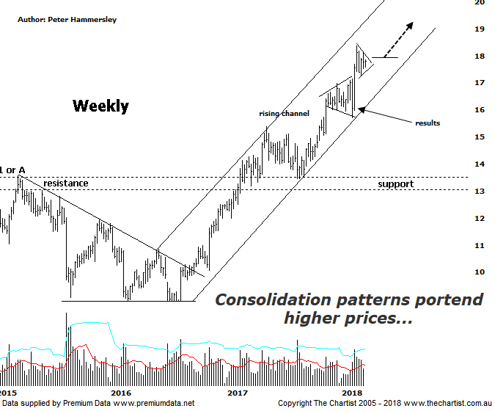

Bottom Line
19/3:
Daily Trend: Up
Weekly Trend: Up
Monthly Trend: Up
Support Levels: $17.14 - $16.99 / $15.71 - $15.39
Resistance Levels: $18.36 (All-time high)
Video Analysis
Watch video analysis here
Technical Discussion
Computershare (CPU) is engaged in the operation of investor services, plan services, communication services, business services, stakeholder relationship management services and technology services. Its sections include Asia, Australia and New Zealand, Canada, Continental Europe; United Kingdom, Channel Islands, Ireland & Africa, and the United States of America. The investor services operations include the provision of registry maintenance and related services. The plan services operations include the provision of administration and related services. The communication services operations include scanning and electronic delivery. The business services operations include the provision of bankruptcy and mortgage servicing activities. The stakeholder relationship management services group provides investor communication and management information services. Its technology services include the provision of software, specializing in share registry and financial services. For the six months ending the 31st of December 2017 revenues increased 12% to $1.12B. Net income before extraordinary items decreased 14% to $128.8M. Revenues highlight the United States section increase of 23% to $555.9M and the Asia section increase of 13% to $76.2M. Net income was offset by Corporate Services which increased 21% to $13.5M. Broker consensus is “Hold”. The dividend yield is 2.0%.
Reasons to be bullish:
→ Full-year guidance is now projected to be 12.5% growth in earnings per share.
→ US tax reform could be beneficial.
→ A $200m bi-back has been announced.
→ Profits should be boosted from the contract with UKAR in FY19.
→ Management continue to concentrate on cost reductions.
→ The increased dividend and reduced gearing highlights the cash generating model.
Strong earnings growth.
→ A healthy retracement is unfolding following a very strong uptrend.
There was plenty going on in the chart of CPU last time where we were concentrating on the weekly timeframe. We’ll stick with the larger degree patterns this evening which brings us back to the standout patterns. The first is the rising channel with price hovering around the lower boundary during our last review. The immediate pattern of interest was an expanding triangle which is quite rare. As with the more conventional triangle, a break through the upper trend line is required before getting overly confident which is exactly what’s transpired. Once again, it was results that triggered the recent leg higher which also led to an upside break out of the consolidation pattern. Not that price has got on with the job although the sideways consolidation over the past three weeks continues to set the stage for higher prices. There is minor bearish divergence in place on this chart although without the deep “V” it certainly isn’t a textbook example, yet it still needs watching. On the daily chart (not shown) a small triangle appears to be unfolding meaning an upside break could transpire over next week or two. This would likely be the trigger for a continuation up toward the upper trend line of the rising channel which offers a decent percentage gain from current levels. It’s also worth remembering that price can break through the upper or lower boundary of the channel briefly without invalidating the pattern. In other words, what essentially is diagonal resistance could even be overcome during the next leg higher - assuming it transpires. Volume is doing everything asked of it, as it’s increased during the recent leg higher and started to taper off during the recent consolidation which is precisely what we’d expect of a company in an uptrend. Despite significant strength over the past few months brokers continue to dislike the company with not one putting forward a “buy” recommendation following recent results. This is of no concern to us as the technical picture continues to advocate higher prices.
Trading Strategy
I’m not going to make a formal recommendation for a couple of reasons. First of all, there is the potential for bearish divergence to trigger and secondly there is a recommendation in the ASX Power Setups section if you want to follow it. However, should the divergence invalidate or unwind I may put forward an alternative setup for longer-term traders and investors. Let’s not forget this is a company that’s just broken higher out of a significant zone of resistance which also coincides with all-time highs. This is extremely positive.

