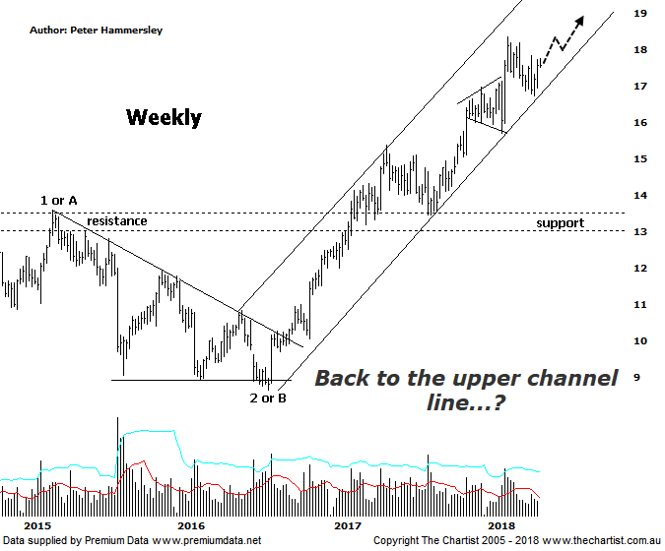

Bottom Line
8/5:
Daily Trend: Up
Weekly Trend: Up
Monthly Trend: Up
Support Levels: $15.71 - $15.39
Resistance Levels: $18.36 (All-time high)
Video Analysis
Watch video analysis here
Technical Discussion
Computershare (CPU) is engaged in the operation of investor services, plan services, communication services, business services, stakeholder relationship management services and technology services. Its sections include Asia, Australia and New Zealand, Canada, Continental Europe; United Kingdom, Channel Islands, Ireland & Africa, and the United States of America. The investor services operations include the provision of registry maintenance and related services. The plan services operations include the provision of administration and related services. The communication services operations include scanning and electronic delivery. The business services operations include the provision of bankruptcy and mortgage servicing activities. The stakeholder relationship management services group provides investor communication and management information services. Its technology services include the provision of software, specializing in share registry and financial services. For the six months ending the 31st of December 2017 revenues increased 12% to $1.12B. Net income before extraordinary items decreased 14% to $128.8M. Revenues highlight the United States section increase of 23% to $555.9M and the Asia section increase of 13% to $76.2M. Net income was offset by Corporate Services which increased 21% to $13.5M. Broker consensus is “Hold”. The dividend yield is 2.1%.
Reasons to be bullish:
→ Full-year guidance is now projected to be 12.5% growth in earnings per share.
→ US tax reform could be beneficial.
→ A $200m bi-back has been announced.
→ Profits should be boosted from the contract with UKAR in FY19.
→ Management continue to concentrate on cost reductions.
→ The increased dividend and reduced gearing highlights the cash generating model.
→ Strong earnings growth.
→ A healthy retracement is unfolding following a very strong uptrend.
The better patterns remain on this weekly chart and as such we’ll stick with it. The headline pattern recently has been the rising channel which has been in motion since mid-2016. There’s no indication that price is going to break through the upper or lower boundary any time soon. In fact, since our last review the lower boundary has been tagged to the cent although once again this resulted in demand returning, with a decent bounce unfolding over the past couple of weeks. A quick look at the daily timeframe shows price has just broken higher out of a small falling channel or flat pattern. The only slight concern is that volume has tapered substantially during recent strength which suggests there isn’t a great deal of demand. This needs to change if the strong prior uptrend is to reignite with any degree of attitude over the coming days. Either way, unless the lower boundary of the channel is breached the risk remains to the upside. From an Elliott stance price should be heading higher within wave-3 or-B. On the positive side of things, the wave equality projection at $15.65 has been overcome which implies price is heading higher within wave-3. To constitute an extension price needs to travel 1.618x the length of wave-1 which provides a target at $19.98 which isn’t too far above current levels. Just remember though, this is the minimum expectation so there’s every chance that price will extend even further. The other positive aspect of this chart is the sideways consolidation that commenced all the way back in 2007. It was a wide trading range although until the recent breakout price had been meandering sideways which undoubtedly set the stage for the recent impulsive price action. Suffice to say, the recent breakout should have plenty of legs in it before concluding.
Trading Strategy
With price recently hitting the lower boundary of the rising channel and rejecting there is a case for jumping on around current levels, with the expectation that price will head up toward the upper boundary of the pattern which offers reasonable upside potential. The protective stop will need to be placed just beneath the prior pivot low at $16.70 or even just beneath the lower boundary of the channel to allow a little more wiggle room. There is no formal recommendation but if you want to be involved in an exceptionally strong trending stock with upside potential then CPU is a worthy contender.

