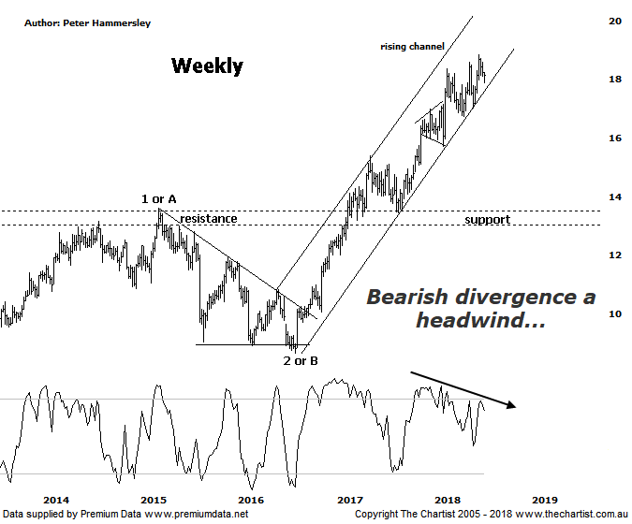

Bottom Line
11/7:
Daily Trend: Down
Weekly Trend: Up
Monthly Trend: Up
Support Levels: $16.99 - $16.95 / $15.71 - $15.39
Resistance Levels: $18.85 (All-time high)
Video Analysis
Watch video analysis here
Technical Discussion
Computershare (CPU) is engaged in the operation of investor services, plan services, communication services, business services, stakeholder relationship management services and technology services. Its sections include Asia, Australia and New Zealand, Canada, Continental Europe; United Kingdom, Channel Islands, Ireland & Africa, and the United States of America. The investor services operations include the provision of registry maintenance and related services. The plan services operations include the provision of administration and related services. The communication services operations include scanning and electronic delivery. The business services operations include the provision of bankruptcy and mortgage servicing activities. The stakeholder relationship management services group provides investor communication and management information services. Its technology services include the provision of software, specializing in share registry and financial services. For the six months ending the 31st of December 2017 revenues increased 12% to $1.12B. Net income before extraordinary items decreased 14% to $128.8M. Revenues highlight the United States section increase of 23% to $555.9M and the Asia section increase of 13% to $76.2M. Net income was offset by Corporate Services which increased 21% to $13.5M. Broker consensus is “Hold”. The dividend yield is 2.1%.
Reasons to be bullish:
→ Full-year guidance is now projected to be 12.5% growth in earnings per share.
→ US tax reform could be beneficial.
→ A $200m bi-back has been announced.
→ Profits should be boosted from the contract with UKAR in FY19.
→ Management continue to concentrate on cost reductions.
→ The increased dividend and reduced gearing highlights the cash generating model.
→ Strong earnings growth.
→ A healthy retracement is unfolding following a very strong uptrend.
We have been concentrating our efforts on the weekly chart of CPU simply because it shows the clearer patterns. It’s also an uncomplicated chart with the headline pattern being the rising channel. Last time, price had hit the lower trend line of the channel and started to head higher which kept the door open for higher prices. We haven’t been disappointed over the past few weeks with some decent headway being made. That said, price has been retracing recently and it could be that the lower trend line is going to come under pressure again. One of the reasons for suspecting this outcome is that Type-A bearish divergence is in place with price making a higher high whilst our oscillator has failed to confirm by making a lower high. This doesn’t automatically advocate lower prices, but it does suggest that an interim top is in place which will not be exceeded until our oscillator unwinds into the oversold position, which on this larger timeframe is going to take several weeks as opposed to days. As long as the lower trend line continues to attract buyers, as it has in the past there’s no reason why the strong uptrend that commenced back in August 2016 can’t continue. Nothing changes regarding the wave count with wave-3 or-C taking price higher. The more bullish prior scenario should be the way forward which comes down to the wave equality projection at $15.65 being overcome by a substantial margin. Assuming wave-3 extends, there’s no reason why the 1.618 projection sitting at $19.98 can’t be attained over the coming weeks. It would now take a push beneath $13.56 to suggest all is not well although a decline of that magnitude is looking unlikely. The risk remains to the upside, albeit the bearish divergence needs to either invalidate are unwind before the trend continues.
Trading Strategy
Trading channels is one of the simplest strategies available, with these weekly timeframes still offering plenty of upside. That said, with the bearish divergence in play we cannot make a formal recommendation at this stage. However, if our oscillator rotates back down into the oversold position, coinciding with price hitting the lower trend line then an opportunity will arise. In the meantime, we’ll continue to leave well alone as there are better opportunities elsewhere.

