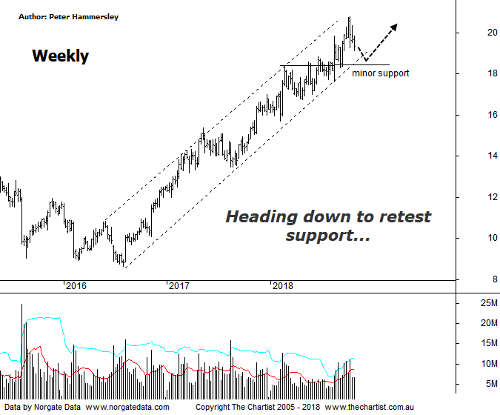
Bottom Line
25/10:
Daily Trend: Down
Weekly Trend: Up
Monthly Trend: Up
Support Levels: $18.31 / $17.62 / $16.99 - $16.95
Resistance Levels: $20.80 (All-time high)
Video Analysis
Watch video analysis here
Technical Discussion
Computershare (CPU) is engaged in the operation of investor services, plan services, communication services, business services, stakeholder relationship management services and technology services. Its sections include Asia, Australia and New Zealand, Canada, Continental Europe; United Kingdom, Channel Islands, Ireland & Africa, and the United States of America. The investor services operations include the provision of registry maintenance and related services. The plan services operations include the provision of administration and related services. The communication services operations include scanning and electronic delivery. The business services operations include the provision of bankruptcy and mortgage servicing activities. The stakeholder relationship management services group provides investor communication and management information services. Its technology services include the provision of software, specializing in share registry and financial services. Broker consensus is “Hold”. The dividend yield is 2.1%.
Reasons to be bullish:
→ Recent results keep the company on track for multi-year growth.
→ Good momentum in the US mortgage servicing business.
→ Margin income should be a key contributor to earnings growth in FY19.
→ Cost reductions remain a key component.
→ Benefiting from higher interest rates.
→ US tax reform could be beneficial.
→ Profits should be boosted from the contract with UKAR in FY19.
Considering the fall from grace that’s been seen in many companies over the past few weeks, CPU has remained reasonably resilient. Yes, it has been heading lower but price action has been choppy and messy in nature as opposed to impulsive which is a good trait to have. The trend that kicked into gear in mid-2016 is still intact with price heading higher within the confines of the rising channel as annotated. Also, on the positive side of things the zone of resistance has been overcome by a reasonable margin with price now heading back to retest it as new support. Indeed, the zone of support is now within touching distance meaning an important juncture is almost upon us. In round numbers, as long as price can stay above $18.00 there is still a good chance of avoiding a deeper retracement. It will be difficult for any stock outside of the gold sector to gain upside traction in a market in retracement mode although if we had to pick one then Computershare would be near the top of the list. It almost goes without saying that a push beneath the lower boundary of the zone of support would be less than ideal, especially as it would also take price beneath the lower trend line of the channel which would probably be more significant should it transpire. For now though, we need to be on the lookout for buyers returning around the lower trend line of the channel. There is still no high probability wave count on this weekly chart which comes down to the fact that price tends to step its way higher as opposed to making impulsive moves followed by deeper retracements which is much more textbook.
Trading Strategy
“…One of our trading rules is that we cannot put forward a formal recommendation when bearish divergence is in place. With this being the case here, we must either let our indicator unwind into the oversold position - or invalidate…” The prior proved to be the way forward with the resilience seen of late pushing our oscillator deep into the overbought position, thus nullifying the bearish divergence. This is positive as it’s one less hurdle to overcome. Either way, there is no formal recommendation although if you are aggressive you could look for a buying opportunity following signs of strength around the lower trend line of the channel and the minor horizontal line of support. Just be aware of what the broader market is doing at the time of the setup.

