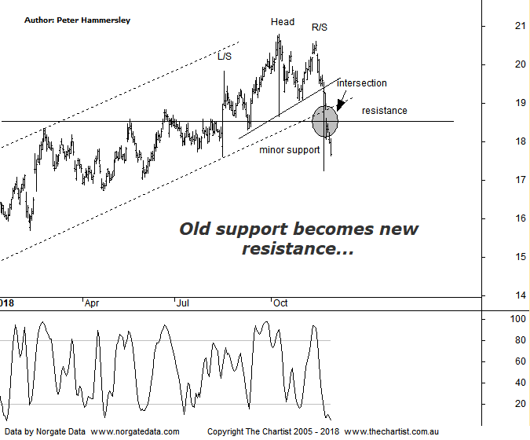
Bottom Line
26/11:
Daily Trend: Down
Weekly Trend: Down
Monthly Trend: Down
Support Levels: $16.99 - $16.95
Resistance Levels: $20.80 (All-time high)
Video Analysis
Watch video analysis here
Technical Discussion
Computershare (CPU) is engaged in the operation of investor services, plan services, communication services, business services, stakeholder relationship management services and technology services. Its sections include Asia, Australia and New Zealand, Canada, Continental Europe; United Kingdom, Channel Islands, Ireland & Africa, and the United States of America. The investor services operations include the provision of registry maintenance and related services. The plan services operations include the provision of administration and related services. The communication services operations include scanning and electronic delivery. The business services operations include the provision of bankruptcy and mortgage servicing activities. The stakeholder relationship management services group provides investor communication and management information services. Its technology services include the provision of software, specializing in share registry and financial services. Broker consensus is “Hold”. The dividend yield is 2.3%.
Reasons to be bullish:
→ Recent results keep the company on track for multi-year growth.
→ Good momentum in the US mortgage servicing business.
→ Margin income should be a key contributor to earnings growth in FY19.
→ Cost reductions remain a key component.
→ Benefiting from higher interest rates.
→ US tax reform could be beneficial.
→ Profits should be boosted from the contract with UKAR in FY19.
We’ve been concentrating on the weekly chart of CPU of late, with the headline pattern being the rising channel that commenced all the way back in 2016. Our expectation over the past few weeks was to head down to the lower boundary before reversing higher. We certainly got weakness although the lower trend line of the channel has been overcome in a straight-line movement. In fact, price gapped down through the lower boundary which is something that often occurs. I am flipping to the daily chart this evening as it shows the line of support in more detail. This shows good confluence with the channel line although both have been penetrated in a move that has stuck. In other words, diagonal and horizontal support has now become resistance which is never a good trait. The other pattern of interest is a Head & Shoulders which is also better viewed on this daily timeframe. The neckline has been overcome, with the measured move out of the pattern coming in just above $17.00 which isn’t too far beneath current levels. This brings us to the wide-ranging bar on the 08th of October, where price dived intraday only to rally and close near the highs of the session. This would normally be viewed in a positive light although there was no follow-through to the upside. This is why we are always cautious of one day reactions following announcements, which was exactly the situation here. It's the following few days that provide a big clue as to which direction price is going to take. For now the risk remains to the downside, with the target being the H&S projection as a minimum with a good possibilty of seeing lower levels tagged.
Trading Strategy
If you are more aggressive you could short-sell around current levels with the protective stop set just beneath the new line of resistance at $20.55. There is no high probability target area bigger picture although remember the H&S projection aligns with $17.00 which doesn’t provide an attractive enough risk/reward for us. Also, this is an exceptionally strong trending stock over the longer-term which isn’t the best environment for short set-ups. As such, we’ll watch only although the setup is there if you want to follow it.

