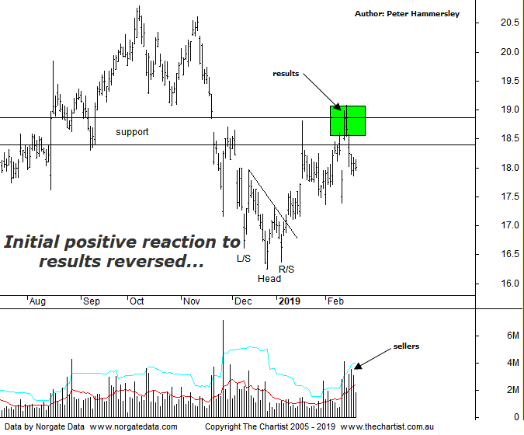

Bottom Line
20/2:
Daily Trend: Down
Weekly Trend: Up
Monthly Trend: Down
Support Levels: $16.25 / $15.71
Resistance Levels: $19.08 / $20.80 (All-time high)
Video Analysis
Watch video analysis here
Technical Discussion
Computershare (CPU) is engaged in the operation of investor services, plan services, communication services, business services, stakeholder relationship management services and technology services. Its sections include Asia, Australia and New Zealand, Canada, Continental Europe; United Kingdom, Channel Islands, Ireland & Africa, and the United States of America. The investor services operations include the provision of registry maintenance and related services. The plan services operations include the provision of administration and related services. The communication services operations include scanning and electronic delivery. The business services operations include the provision of bankruptcy and mortgage servicing activities. The stakeholder relationship management services group provides investor communication and management information services. Its technology services include the provision of software, specializing in share registry and financial services. Broker consensus is “Hold”. The dividend yield is 2.3%.
Reasons to be bullish:
→ Recent results keep the company on track for multi-year growth.
→ Good momentum in the US mortgage servicing business.
→ Margin income should be a key contributor to earnings growth in FY19.
→ Cost reductions remain a key component.
→ Benefiting from higher interest rates.
→ US tax reform could be beneficial.
→ Profits should be boosted from the contract with UKAR in FY19.
Despite the significant downtrend, there was a glimmer of hope during our last review of CPU which came down to the Head & Shoulders reversal pattern triggering. Also, price had just pushed higher out of a box pattern which again added weight to the case for higher prices. However, although strength kicked in immediately it was soon apparent that the zone of resistance was going to prove to be formidable. The day following our last look at the stock, price gapped higher, headed toward the upper boundary of the zone of resistance only to be followed by immediate weakness resulting in a close near the session’s lows. Another attempt at the $19.00 area has been witnessed although once again there’s been no follow-through to the upside. It’s also worth noting that a week ago results were announced which resulted in a strong gap higher and a high close coupled with a large increase in volume which on the face of it is positive. However, this is why we don’t read too much into one day’s price action as in this instance it proved to be a false dawn with sellers stepping up the very next session. It’s always worth remembering that we need to let the dust settle following announcements as these one-off spikes can be frustrating and misleading. Indeed, we have seen several stocks recently showing similar price action, with price heading higher following results only for strength to fade immediately. It would now take a push above the recent pivot high and the upper boundary of the typical retracement zone at $19.08 before thinking in terms of something more bullish unfolding. The high-volume retracement over the past few days isn’t a good start regarding the more bullish scenario taking place. On the weekly chart, there is now scope for a larger corrective pattern to unfold which could take price down toward the $14.00 area.
Trading Strategy
“…It seems a long time since we’ve put forward a formal recommendation in the position status page although that’s precisely what we are going to do here. The strategy is to buy following a push above today’s high at $17.73 with the protective stop placed just beneath the lower boundary of the box pattern at $17.10 which is aggressive…” We are holding long positions although the lack of follow-through mentioned above means we are going to take decisive protective action. We’ll place the protective stop just beneath yesterday’s low at $17.85 which should result in around a breakeven trade when taking the dividend into account. There’s no point holding and hoping, especially with the patterns deteriorating recently. Plenty of stocks are trending and these are the ones we need to be involved with. It’s important to let the winners run and cut the underachievers down at the earliest opportunity.

