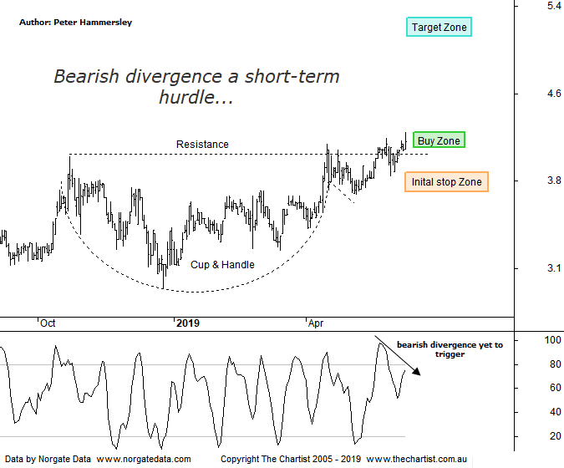

Bottom Line
11/6:
Daily Trend: Up
WeeklyTrend: Up
Monthly Trend: Up
Support Levels: $3.76 - $3.71
Resistance Levels: N/A
Video Analysis
Watch Video Analysis Here
Technical Discussion
PWR Holdings (PWH) is engaged in the design, engineering, production, testing, validation and sales of customized aluminum cooling products and solutions to the motorsports, automotive original equipment manufacturer (OEM), automotive aftermarket and technologies sectors for domestic and international markets. The Company's segments include PWR Performance Products and C&R Racing. The PWR Performance Products segment comprises its Australian and European operations, and operates within sectors, primarily driven by the motorsports and automotive aftermarket sectors. The C&R Racing segment comprises the United States operations of the Company. It operates manufacturing facilities and sales offices in Australia, the United Kingdom and the United States, and sells its products to customers in various countries throughout the world. For the six months ended the 31st of December 2018 revenues increased 22% to A$24.8M. Net income before extraordinary items increased 67% to A$3.1M. Revenues reflect the PWR Performance Products segment increase of 32% to A$19.4M and the United Kingdom segment increase of 53% to A$7.2M. Broker consensus is “buy”. The dividend yield is 1.8%.
Reasons to be bullish:
→ Momentum set to continue due to motorsports and the automotive aftermarket.
→ Demand from key supercar manufacturers remains robust.
→ A high-quality business with a focus on high-end cooling solutions.
→ A niche business, suppressing exposure to a downturn in the economic cycle.
→ Broken higher out of a long consolidation phase.
Since October of last year price has been range bound, albeit it’s been a wide range. The good news is that the prior trend was exceptionally strong meaning at this stage we are viewing the consolidation as being healthy. What’s caught our attention here though is the Cup & Handle which is a pattern that’s been cropping up a lot on the charts recently. These are one of the best continuation patterns available to us, especially when the breakout transpires which is a box that can be ticked in this case. In fact, the breakout unfolded in late May although price didn’t immediately get on with the job. Quite often we’ll see a retest of the breakout area although in this instance price has been consolidating around the line of resistance which is fine as long as price breaks to the upside. Indeed, today was a better session, albeit the close was off the highs of the session. Volume was also very low which is the opposite of what we need to see if a strong leg higher is about to unfold. Volume can be thin on this stock at times although the guideline remains - increasing volume during strength provides increased confidence that a breakout is going to stick, which at this stage isn’t the case. Another short-term headwind is Type-A bearish divergence with price making a higher high whilst our oscillator has failed to confirm by making a lower high. It’s yet to trigger, although if it does a little more patience is going to be required until our oscillator rotates back down to the oversold position although this could unfold within a week or two meaning it’s not major reason for concern. Either way, it’s a good-looking chart and there’s no reason why the target area as annotated can’t be achieved further down the track.
Trading Strategy
As we’ve mentioned several times before, we don’t put forward a formal recommendation when bearish divergence is in place. It’s one of our trading rules. As such, we’ll put this on the watchlist with a view to making a recommendation when the divergence either invalidates or unwinds, so keep a close eye on the position status page as it may pop up without making another formal review.

