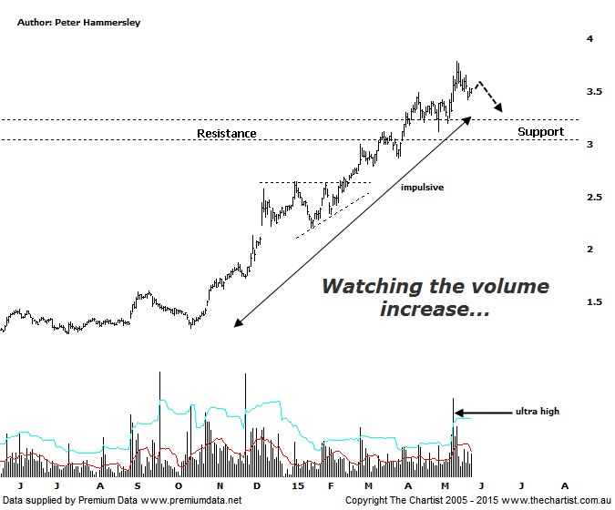

Bottom Line
26/5:
Daily Trend: Down
WeeklyTrend: Up
Monthly Trend: Up
Support levels: $3.12 / $2.99 / $2.81
Resistance levels: $3.79/ $4.11
Video Analysis
Watch Video Analysis Here
Technical Discussion
Qantas Airways is involved in the operation of international and domestic air transportation services, the provision of freight services and the operation of a Frequent Flyer loyalty program. The Company’s main business is the transportation of customers using two complementary airline brands which are Qantas and Jetstar. It also controls subsidiary businesses including other airlines and businesses in specialist markets, such as Q Catering. The Company operates in four sections; Qantas Domestic, Qantas International, Qantas Loyalty and Qantas Freight. For the six months ending the 31st of December 2014 revenues increased 2% to A$8.07B. Net income totalled A$203M vs. loss of A$235M Broker consensus is currently “Buy”. No dividend is paid.
Reasons to be more optimistic:
→ Cash flow should remain positive for the foreseeable future with the company also be confident of a credit rating upgrade.
→ Traffic for February shows continued revenue momentum with the yields both domestically and internationally on the rise.
→ The company has updated guidance for the first half with a profit of between $300m and $350m anticipated.
→ Cost cutting measures are continuing.
→ Market dynamics have been improving, especially domestically.
On the day of our last review price had just broken through the upper boundary of the zone of resistance which portended a consolidation prior to another leg higher. That’s pretty much what’s transpired with old resistance/new support being tested and clearly rejected with buyer’s once again chasing price higher. It’s been a stellar come-back for Qantas since December 2013 with the company gaining almost 300% up to the pivot high made a couple of weeks ago. Some profit taking has been witnessed over the past couple of weeks but it’s certainly nothing to be discouraged about in the bigger scheme of things. Price could even come-back to retest the zone of support again and still be in a strong position. The only slight reason for concern is the large increase in volume which coincided with the recent pivot high. It’s uncanny how often volume bubbles coincide with a significant top which means we have to tread carefully over the next week or two. If downside traction does take hold then a deeper, albeit healthy retracement could be in its early stages. It’s also worth pointing out that several large brokers have put out “buy” signals recently which automatically brings out the contrarian in us. This is perhaps being a little cynical but it’s amazing how often some brokers jump on the bandwagon late; just another reason to not get carried away and buy just for the sake of it.
Trading Strategy
Although it’s always good to add strong trending stocks to your portfolio we don’t recommend jumping on right here and now. As mentioned above, the large increase in volume at the recent pivot high could be an early warning sign of a pending longer pause for breath or even a deeper pull-back. If the recent profit taking only triggers a sideways meander then our interest will be rekindled. For the moment we’ll remain side-lined and watch from a distance.

