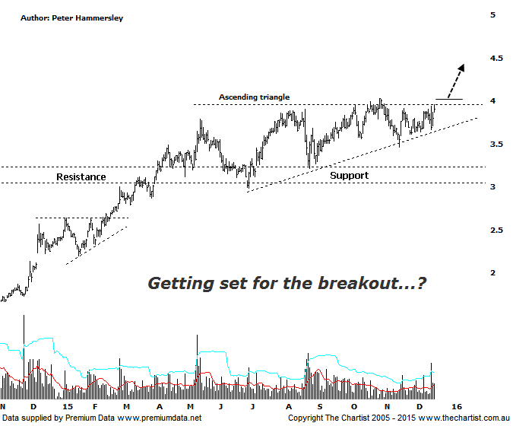

Bottom Line
17/12:
Daily Trend: Up
WeeklyTrend: Up
Monthly Trend: Up
Support levels: $3.46 / $2.98 / $2.58
Resistance levels: $4.03 / $6.06
Video Analysis
Watch Video Analysis Here
Technical Discussion
Qantas Airways is involved in the operation of international and domestic air transportation services, the provision of freight services and the operation of a Frequent Flyer loyalty program. The Company’s main business is the transportation of customers using two complementary airline brands which are Qantas and Jetstar. It also controls subsidiary businesses including other airlines and businesses in specialist markets, such as Q Catering. The Company operates in four sections; Qantas Domestic, Qantas International, Qantas Loyalty and Qantas Freight. For the year ending the 30th of June 2015 revenues increased 3% to A$15.82B. Net income totalled A$557M against a loss of A$2.84B. Revenues reflect the Qantas International section increase of 5% to A$4.88B. Broker consensus is strongly “Buy”. No dividend is paid.
Reasons to be more optimistic.
→ Lower fuel costs improves profitability.
→ $1billion in capital returns is feasible.
→ Trading at a large discount to valuation.
→ Cash flow should remain positive for the foreseeable future with the company also confident of a credit rating upgrade.
→ The company has updated guidance for the first half with a profit of between $300m and $350m anticipated.
→ Cost cutting measures are continuing.
→ Market dynamics have been improving, especially domestically.
There have been eight “Buy” recommendations put out by brokers this month alone which is quite startling to say the least. One of the reasons being that November traffic statistics continue to climb which has been the trait over the past few months. There’s also the bonus of continued lower fuel costs and the possibility of a special dividend being announced this year although this is speculation at this time. Undoubtedly the fundamentals are looking much better than they have over the past few years although of course this is already built into prices – at least to some extent. We prefer to concentrate on the technical picture which has also been looking very healthy. In many ways it’s a simple chart to take a look at with a strong impulsive movement higher being followed by an ascending triangle. The lower boundary had enticed a few buyers back into the stock during our last review which portended another leg higher which is precisely what’s unfolded. Once again price is tagging the upper boundary of the pattern with a break above the recent pivot high at $4.03 being a bullish proposition; a close above that level would be even better as it would reduce the risk of seeing a “fakeout” which is a pattern that has been cropping up too much over recent months and for that matter even years. On the flip side, it would take a push beneath $2.98 to suggest a much deeper retracement is going to unfold although this isn’t our highest expectation. The patterns look bullish and all that’s left is to see our wanted breakout.
Trading Strategy
One thing about triangles is that they almost always present a low risk entry which of course is a prerequisite before getting involved. The strategy here is to buy following a push above $4.03, or you could wait until price closes above that level for further confirmation before initiating positions. The initial stop should be placed one tick beneath Tuesday’s low at $3.65. The target is the measured move out of the triangle sitting up around $5.00 although bigger picture there is even further upside available.

