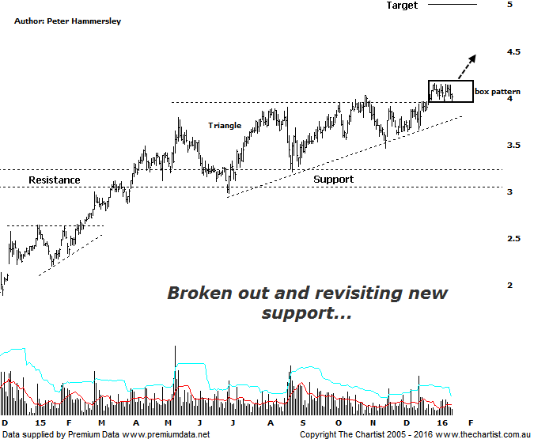
Bottom Line
18/1:
Daily Trend: Down
WeeklyTrend: Up
Monthly Trend: Up
Support levels: $3.46 / $2.98 / $2.58
Resistance levels: $4.16 / $6.06
Video Analysis
Watch Video Analysis Here
Technical Discussion
Qantas Airways is involved in the operation of international and domestic air transportation services, the provision of freight services and the operation of a Frequent Flyer loyalty program. The Company’s main business is the transportation of customers using two complementary airline brands which are Qantas and Jetstar. It also controls subsidiary businesses including other airlines and businesses in specialist markets, such as Q Catering. The Company operates in four sections; Qantas Domestic, Qantas International, Qantas Loyalty and Qantas Freight. For the year ending the 30th of June 2015 revenues increased 3% to A$15.82B. Net income totalled A$557M against a loss of A$2.84B. Revenues reflect the Qantas International section increase of 5% to A$4.88B. Broker consensus is strongly “Buy”. No dividend is paid.
Reasons to be more optimistic.
Lower fuel costs improves profitability.
→ $1billion in capital returns is feasible.
→ Trading at a large discount to valuation.
→ Cash flow should remain positive for the foreseeable future with the company also confident of a credit rating upgrade.
→ The company has updated guidance for the first half with a profit of between $300m and $350m anticipated.
→ Cost cutting measures are continuing.
→ Market dynamics have been improving, especially domestically.
It’s less than two weeks since our last look at QAN but the resilience being shown means it’s time to take another look. The positive last time around was the upper boundary of the ascending triangle being overcome which in essence means horizontal resistance was also penetrated. This often results in price coming back or consolidating above old resistance/new support which is exactly what’s been unfolding over the past few days. Also note that buyers have been stepping up in this region with the bar on the 11th of January being a prime example of buyer support with price heading down intraday, hitting support and rejecting which is pretty much what transpired today as well. As long as accumulation continues in this area there’s no reason why the longer term uptrend can’t kick back into gear with a degree of attitude. Let’s not forget, since December 2013 it’s been a stellar come-back by Qantas which has been followed by the sideways consolidation within the triangle which can also only be deemed as being healthy in the bigger scheme of things. Everything is aligning quite nicely here and although nothing’s guaranteed the door is now open for further strength. There’s a possibility of seeing some more sideways chop though it certainly wouldn’t be reason for concern should this prove to be the way forward. Although a break back down into the trading range would be less than ideal it would take a probe beneath the prior significant low at $2.98 to take away from the bullish case put forward. The continued decline in the price of oil continues to benefit this company so as long as this trait remains, it can only be a positive.
Trading Strategy
We’ve been very wary of looking for too many breakout trades recently as they’ve had a tendency to fail over the past few months, and for that matter even years. It’s much safer to let the breakout transpire and look to be a buyer following a retest of new support which was exactly our strategy last time around. With this in mind, you could be a buyer following a break up through the recent pivot high at $4.16 with the initial stop placed nice and tight at $3.94. With this type of trade price needs to get on with the job immediately the breakout happens meaning defensive action needs to be taken if anything other transpires. A nice low risk entry although there is no high probability target zone over the short-term meaning a trailing stop will need to be used to manage the position.

