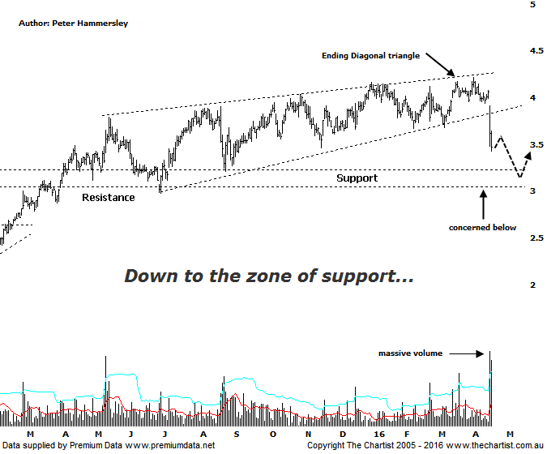

Bottom Line
19/4:
Daily Trend: Down
WeeklyTrend: Down
Monthly Trend: Down
Support levels: $2.98 / $2.58
Resistance levels: $4.21 / $6.06
Video Analysis
Watch Video Analysis Here
Technical Discussion
Qantas Airways is involved in the operation of international and domestic air transportation services, the provision of freight services and the operation of a Frequent Flyer loyalty program. The Company’s main business is the transportation of customers using two complementary airline brands which are Qantas and Jetstar. It also controls subsidiary businesses including other airlines and businesses in specialist markets, such as Q Catering. The Company operates in four sections; Qantas Domestic, Qantas International, Qantas Loyalty and Qantas Freight. For the six months ending the 31st of December 2015 revenues increased 5% to A$8.46B. Net income increased from A$203M to A$688M. Revenues reveal the Qantas International section increase of 9% to A$2.66B. Broker consensus is strongly “Buy”. No dividend is paid.
Reasons to remain optimistic (caution short term).
→ Capital returns circa $1bn are feasible.
→ Lower fuel costs improve profitability.
→ The company still looks attractive when compared to global comparables.
→ A $500m on market buyback has been announced.
→ Cash flow should remain positive for the foreseeable future with the company also confident of a credit rating upgrade.
→ Cost cutting measures are continuing.
→ Market dynamics have been improving, especially domestically.

The big news yesterday was the reduced revenue conditions which appeared to come as a complete surprise to market participants. This fact was even more significant considering the company has been extremely bullish over previous months which was probably what investors found alarming. The change appears to have been caused by falling consumer demand within Australia. Management is reducing domestic capacity in the June quarter whilst increasing capacity elsewhere. Be this as it may, yesterday’s big fall can’t be overlooked; not so much because of the fundamental change but more because our bearish trigger put forward during the last review has been exceeded. Funnily enough, no fewer than five brokers came out with “buy” recommendations yesterday which is thought-provoking to say the least. Getting back to the chart shows that the Rising wedge or (Ending diagonal triangle) has proved to be significant with the lower boundary being smashed yesterday. With this type of structure, the origin of the pattern is the target although yesterday’s sell-off has already taken price halfway to hitting that projection around $3.00. In fact, that aforementioned target aligns very nicely with a zone of support which increases its significance. All things being equal we’d expect those lower levels to come under pressure in the not too distant future. Should buyers return in numbers then a potential buying opportunity will be staring us in the face. For now though, we have to sit back and see whether the intensity of the sell-off dissipates as price draws toward the zone of support.
Trading Strategy
Bearish divergence is evident on the weekly chart (not shown) although our oscillator is more than halfway to making it back down into the oversold position. The technicals mentioned above also increase the chances of the anticipated deeper retracement unfolding. What we need is for price to hit the zone of support (as well as the measured move out of the rising wedge) as our indicator unwinds fully into the oversold position. This will then present a low risk entry. A break straight down through the zone of support opens the door for a much deeper retracement although we’ll take a close look at lower targets if the patterns deteriorate further.

