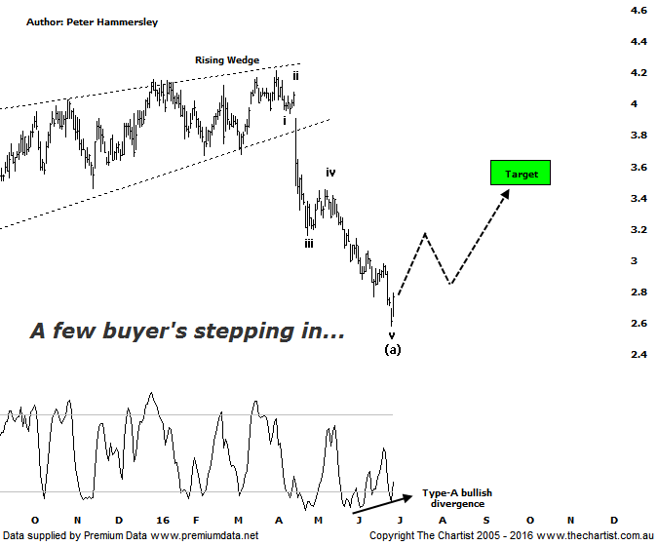

Bottom Line
29/6:
Daily Trend: Down
WeeklyTrend: Down
Monthly Trend: Down
Support levels: $2.58 / $2.19
Resistance levels: $3.39 - $3.59 / $4.21
Video Analysis
Watch Video Analysis Here
Technical Discussion
Qantas Airways is involved in the operation of international and domestic air transportation services, the provision of freight services and the operation of a Frequent Flyer loyalty program. The Company’s main business is the transportation of customers using two complementary airline brands which are Qantas and Jetstar. It also controls subsidiary businesses including other airlines and businesses in specialist markets, such as Q Catering. The Company operates in four sections; Qantas Domestic, Qantas International, Qantas Loyalty and Qantas Freight. For the six months ending the 31st of December 2015 revenues increased 5% to A$8.46B. Net income increased from A$203M to A$688M. Revenues reveal the Qantas International section increase of 9% to A$2.66B. Broker consensus is “Buy”. No dividend is paid.
Reasons to remain optimistic longer term
→ Capital returns circa $1bn are feasible.
→ Lower fuel costs improve profitability.
→ The company still looks attractive when compared to global comparables.
→ A $500m on market buyback has been announced.
→ Cash flow should remain positive for the foreseeable future with the company also confident of a credit rating upgrade.
→ Cost cutting measures are continuing.
→ Market dynamics have been improving, especially domestically.

A couple of weeks ago we put forward a 5-wave movement off the significant highs as having completed. Not to be, with slightly lower levels being tagged before today’s strong bounce. On the positive side of things we now have a better example of Type-A bullish divergence with a deeper “V” in place. The divergence has also triggered which once again sets the stage for a rally to unfold. In fact, price also hit the 50% retracement level of the whole leg higher today before reversing. Had we witnessed a clearly defined corrective pattern down we’d be confident that a significant low was either locked in, or is just around the corner. However, we’d be pushing our look to suggest the retracement has been a corrective pattern and as such we have to be cognizant that any rally here on in could terminate in the typical retracement zone as annotated sitting between $3.39 - $3.59. However, that still offers plenty of upside over the coming weeks and even months ahead. It’s also worth reiterating that the bearish divergence on the weekly chart (not shown) has fully unwound with our oscillator deep into oversold territory. This doesn’t necessarily portend a leg higher but when you throw this into the mix with other technicals, it adds weight to the case for a bounce. Interestingly enough, several brokers have become a little less bullish on the stock for several reasons which we won’t go into here. This likely also has something to do with the severity of the decline over the past few months.
Trading Strategy
A low risk entry is presenting itself though we stress that at this stage we are looking for a healthy bounce as opposed to an immediate strong impulsive leg up through recovery highs. The strategy is to buy following a push above today’s high at $2.77 with the initial stop placed one tick beneath yesterday’s low at $2.57. Either take profits in the typical retracement zone or tighten the trailing stop as those high levels are approached. This offers a decent risk-adjusted trade. There is no formal recommendation although it’s a nice-looking setup if you want to be involved.

