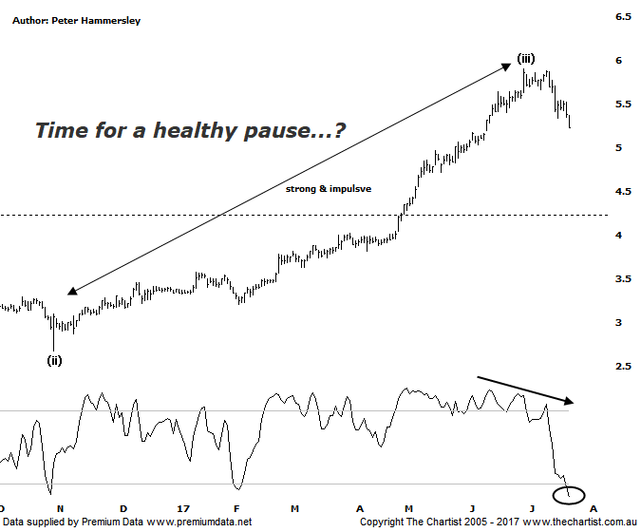

Bottom Line
21/7:
Daily Trend: Down
WeeklyTrend: Up
Monthly Trend: Up
Support levels: $4.66 / $4.21 - $3.90
Resistance levels: $6.06
Video Analysis
Watch Video Analysis Here
Technical Discussion
Qantas Airways is involved in the operation of international and domestic air transportation services, the provision of freight services and the operation of a Frequent Flyer loyalty program. The Company’s main business is the transportation of customers using two complementary airline brands which are Qantas and Jetstar. It also controls subsidiary businesses including other airlines and businesses in specialist markets, such as Q Catering. The Company operates in four sections; Qantas Domestic, Qantas International, Qantas Loyalty and Qantas Freight. For the six months ending the 31st of December 2016 revenues decreased 3% to A$8.18B. Net income decreased 25% to A$515M. Revenues highlight the Qantas International section decrease of 5% to A$2.53B and the Australia section decrease of 4% to A$5.41B. Broker consensus is “Buy”. The dividend yield is 1.3%.
Reasons to remain optimistic longer term (caution short-term):
→ Improved outlook for domestic revenue.
→ Competitive pressure appears to be easing.
→ Strong argument for capital management.
→ Lower fuel costs improve profitability.
→ The company still looks attractive when compared to global comparables.
→ Cash flow should remain positive for the foreseeable future with the company also confident of a credit rating upgrade.
→ Cost cutting measures are continuing.
→ Market dynamics have been improving, especially domestically.
It’s been a remarkable turnaround story for Qantas over the past few years which is reiterated by the fact that between 2007 - 2012 the company lost over 84% in value. It’s certainly suffered severe technical damage although the trend higher in the opposite direction has proved to be just as extraordinary. During our last review price was surging higher up toward all-time highs although there were early signs of distribution. Although slightly higher prices have been achieved it’s been a swift movement down over the past couple of weeks which is likely the result of the bearish divergence noted last time. Our oscillator has now unwound into the oversold position meaning there is scope for a bounce although it’s unlikely that the recent leg South completes the whole corrective pattern. The wave count remains in place with wave-(iii) ideally being locked in at the recent pivot high. As wave-(ii) was a deeper correction we’d expect the current corrective pattern to be exactly the opposite, that is shallow. It could unfold as a flat or even a triangle although both patterns would take several weeks before drawing to a conclusion. If our wave count is correct then all-time highs are at least going to come under pressure in a few weeks time with the potential to head above by a small margin. This should be followed by a more substantial retracement. A comprehensive break up through the recent pivot high at $5.90 will prove us to be incorrect although for the sake of the patterns we’d prefer to see further consolidation in this region before those highs are tested again.
Trading Strategy
Trends like this don’t come around too often and although we’d like to have jumped on, we’ve hardly had an opportunity, at least over more recent times. This is due to the almost parabolic movement higher with nothing in the way of a retracement or consolidation pattern to provide a low risk entry. Should a sideways consolidation form over the coming weeks that will no longer be an issue. As such, we’ll put Qantas toward the top of the watchlist as there is still upside potential, albeit some patience is going to be required.

Disclosure: Nick Radge holds.

