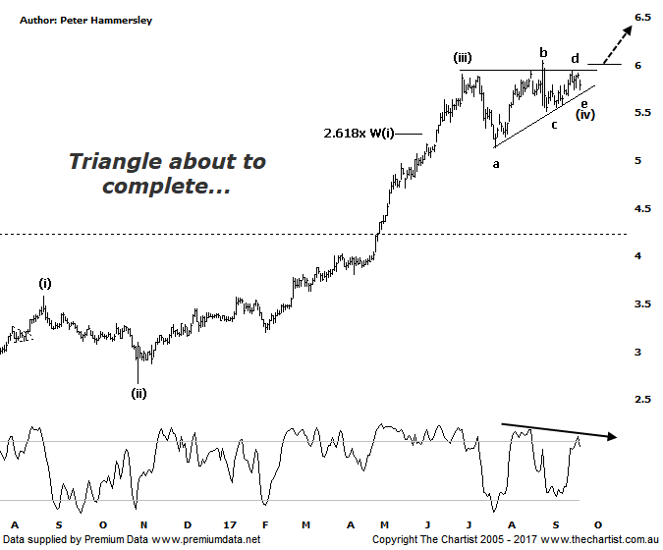

Bottom Line
21/9:
Daily Trend: Up
WeeklyTrend: Up
Monthly Trend: Up
Support levels: $5.13 / $4.66 / $4.21 - $3.90
Resistance levels: $6.06
Video Analysis
Watch Video Analysis Here
Technical Discussion
Qantas Airways is involved in the operation of international and domestic air transportation services, the provision of freight services and the operation of a Frequent Flyer loyalty program. The Company’s main business is the transportation of customers using two complementary airline brands which are Qantas and Jetstar. It also controls subsidiary businesses including other airlines and businesses in specialist markets, such as Q Catering. The Company operates in four sections; Qantas Domestic, Qantas International, Qantas Loyalty and Qantas Freight. For the year ending the 30th of June 2017 revenues decreased 1% to A$16.06B. Net income decreased 17% to A$852M. Revenues reflect the passenger revenue decrease of 1% to A$13.86B and the freight revenue decrease of 5% to A$808M. Net income also reflects the EBITDAR decrease of 3% to A$3.33B. Broker consensus is “Hold”. The dividend yield is 2.4%.
Reasons to remain optimistic longer term (caution short-term):
→ Applying to extend its partnership with Emirates for another five years which is critical to profitability.
→ Looking good value historically, and compared to its global peers.
Improved outlook for domestic revenue.
→ Capital return to shareholders looking increasingly likely.
→ Competitive pressure appears to be easing.
→ Lower fuel costs improve profitability.
→ The company still looks attractive when compared to global comparables.
→ Cost cutting measures are continuing.
Short-term weakness was expected following our last look at Qantas although this hasn’t transpired meaning the flat pattern we were looking for is now less likely to eventuate. Not that strength has been the way forward either, with a sideways consolidation phase continuing over the past few weeks. This has presented us with a triangle which at this stage of the trend is bullish. Triangles usually occur during the wave-(iv) position which provides more evidence that our wave count is correct. Elliott triangles should contain 5-internal swings which is exactly what we currently have. The lower trend line came under pressure today meaning if we are to see an upside breakout then buyers need to step up pretty much immediately - and by that, I mean within a week. A push down through the lower trend line would take us back to the aforementioned flat pattern which would portend a continuation down to the low of wave-a around $5.13 although buyers stepping up at those lower levels would again open the door for the potent prior trend to reignite. It would take a continuation beneath $5.00 to suggest a more significant top is in position although this would be less than ideal regarding the patterns, as well as from a trading point of view. The only reason for concern is Type-A bearish divergence on the weekly chart (not shown). It’s not a strong example but it has triggered meaning we must keep one eye on it as it could potentially stifle any upside break.
Trading Strategy
If you are more aggressive then wait until the high of wave-b at $6.05 is overcome before initiating long positions. Place the initial stop just beneath the prior pivot low at $5.50. The measured move out of the triangle aligns with $6.65 which would be the short-term target. Otherwise, use a trailing stop to manage the position. There is no formal recommendation because of the bearish divergence on the weekly chart although should this dissipate or invalidate we’ll take another look.

Disclosure: Nick Radge holds.

