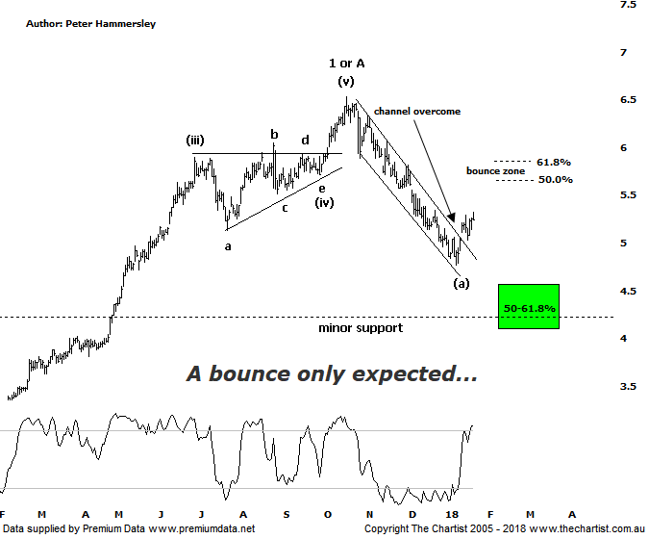

Bottom Line
23/1:
Daily Trend: Up
WeeklyTrend: Down
Monthly Trend: Down
Support levels: $4.55 / $4.09
Resistance levels: $6.53
Video Analysis
Watch Video Analysis Here
Technical Discussion
Qantas Airways is involved in the operation of international and domestic air transportation services, the provision of freight services and the operation of a Frequent Flyer loyalty program. The Company’s main business is the transportation of customers using two complementary airline brands which are Qantas and Jetstar. It also controls subsidiary businesses including other airlines and businesses in specialist markets, such as Q Catering. The Company operates in four sections; Qantas Domestic, Qantas International, Qantas Loyalty and Qantas Freight. For the year ending the 30th of June 2017 revenues decreased 1% to A$16.06B. Net income decreased 17% to A$852M. Revenues reflect the passenger revenue decrease of 1% to A$13.86B and the freight revenue decrease of 5% to A$808M. Net income also reflects the EBITDAR decrease of 3% to A$3.33B. Broker consensus is “Buy”. The dividend yield is 2.7%.
Reasons to remain optimistic longer term (caution short-term):
→ Discipline in the domestic market should result in higher margins and offset high fuel costs and international competition.
→ Strong September quarter revenue
→ Good value relative to historical levels and peers.
→ Applying to extend its partnership with Emirates for another five years which is critical to profitability.
→ Capital return to shareholders looking increasingly likely.
→ Lower fuel costs improve profitability.
→ Cost cutting measures are continuing.
Qantas was heading lower at a rate of knots during our last review within the confines of a falling channel. The problem back then was that although the typical retracement zone was drawing ever closer, it was a straight-line movement down which of course should not complete the whole corrective pattern. As such, we needed to see a bounce and over the past week that’s exactly what’s transpired. At this stage though, that’s all we are looking for - a rally only and not the resumption of the strong prior uptrend. The decline down to the recent pivot low was just short of 27% meaning recent strength is welcomed with open arms. The typical retracement zone as annotated sitting between $5.65 - $5.86 could hold a few sellers, and if a corrective pattern takes price higher then rejection is likely going to be seen at those higher levels. We’d then expect to see another impulsive movement down toward the lower boundary of the target area. The expectation of a deeper retracement is a result of the recent pivot low getting close to the 50% level. Should price reverse down through $4.00 immediately then a more significant top is in place. In fact, the typical retracement zone of the whole leg higher off the June 2012 lows sits between $3.74 - $3.08 which is more than feasible, as well as being a substantial percentage decline from current levels. Just remember, this target area will only come to the fore if the initial target zone is breached. On the weekly chart, the bearish divergence that’s been providing the headwind is no longer an issue with our oscillator now heading higher out of the oversold position which sets the stage for a continued bounce, at least over the coming weeks.
Trading Strategy
A lacklustre bounce into the target area just beneath $6.00 would provide a shorting opportunity for those looking to balance their portfolio although we are not interested in short-selling at this juncture. For one thing, the longer-term trend is still up in the stock, and secondly the broader market risk is still to the upside, despite the recent lack of conviction. Qantas is best left alone for the moment as the larger degree correction continues to unfold.

Disclosure: Nick Radge holds.

