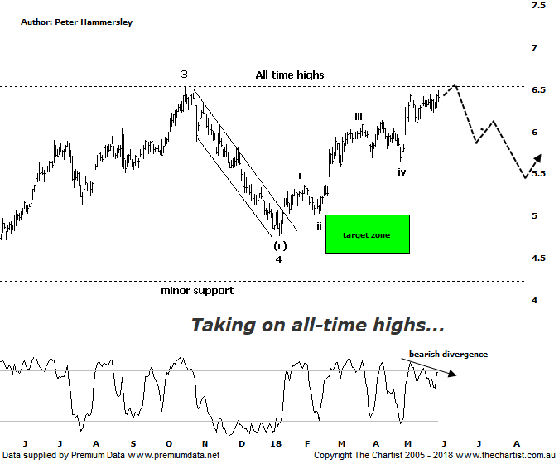

Bottom Line
30/5:
Daily Trend: Up
WeeklyTrend: Up
Monthly Trend: Up
Support levels: $5.33 / $4.77 - $4.55 / $4.09
Resistance levels: $6.53
Video Analysis
Watch Video Analysis Here
Technical Discussion
Qantas Airways is involved in the operation of international and domestic air transportation services, the provision of freight services and the operation of a Frequent Flyer loyalty program. The Company’s main business is the transportation of customers using two complementary airline brands which are Qantas and Jetstar. It also controls subsidiary businesses including other airlines and businesses in specialist markets, such as Q Catering. The Company operates in four sections; Qantas Domestic, Qantas International, Qantas Loyalty and Qantas Freight. For the six months ending the 31st of December 2017 revenues increased 6% to A$8.66B. Net income increased 18% to A$607M. Revenues highlight the Qantas International section increase of 8% to A$3.23B and the Australia section increase of 6% to A$5.75B. Broker consensus is “Buy”. The dividend yield is 2.2%.
Reasons to remain optimistic longer term (caution short-term):
→ Discipline in the domestic market should result in higher margins and offset high fuel costs and international competition.
→ Strong September quarter revenue
→ Good value relative to historical levels and peers.
→ Applying to extend its partnership with Emirates for another five years which is critical to profitability.
→ Capital return to shareholders looking increasingly likely.
→ Lower fuel costs improve profitability.
→ Cost cutting measures are continuing.
Having witnessed an 84% decline down to the December 2013 low it was unlikely that Qantas was going to head into all-time highs just over four years later although that’s exactly what’s transpired. It’s been one of the biggest turnaround stories on the market and there’s no indication that the uptrend is going to come to an abrupt halt. In fact, bigger picture there is room for significantly higher levels to be achieved. Strength since our last review means I can now put forward a more bullish interpretation of the wave count, albeit it isn’t perfect. Wave-4 doesn’t unfold as a clear 3-leg movement although the continuation up toward all-time highs suggests it is locked in. Also, price has terminated in the typical retracement zone before reversing higher which is another box that can be ticked. The real clue is the subsequent rally which has unfolded as an impulsive move. This is a bullish proposition, albeit it appears that smaller degree wave-v is in its latter stages. Rejection around all-time highs would open the door for a 3-wave movement lower, tracing between 50% - 61.8% of the leg higher off the January low. In other words, if price reverses over the coming weeks any subsequent retracement should be minimal and set the stage for the next leg higher. Talking of which, once wave-5 is locked in this should only complete a larger degree wave-(3) which is the reason we remain bullish over the coming months and possibly even years ahead. It would take a push beneath $4.77 to suggest all is not well although a pull-back of that magnitude isn’t looking likely. Bearish divergence is evident on this daily timeframe which could be the trigger for the aforementioned retracement although first of all it needs to trigger, otherwise it’s something to watch only.
Trading Strategy
Should the smaller degree patterns unfold as anticipated then a multi-week leg lower shouldn’t be too far away. As such, we continue to stand aside especially with the bearish divergence hanging over us. That said we are keen to jump onto the longer-term uptrend, so we will be placing Qantas on our watchlist. Until an opportunity arises we’ll continue to monitor the smaller degree patterns.

