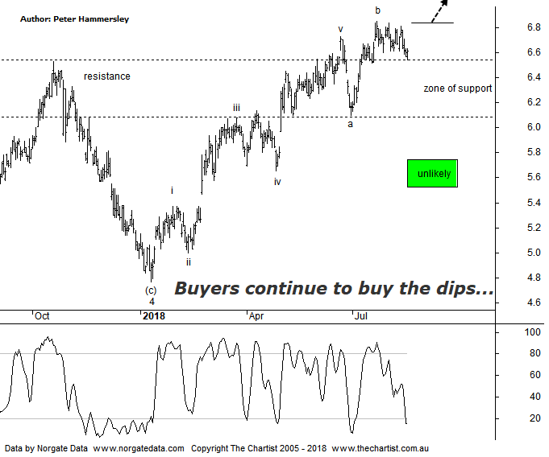

Bottom Line
15/8:
Daily Trend: Down
WeeklyTrend: Up
Monthly Trend: Up
Support levels: $6.10 - $6.05 / $5.33 / $4.77 - $4.55
Resistance levels: $6.85
Video Analysis
Watch Video Analysis Here
Technical Discussion
Qantas Airways is involved in the operation of international and domestic air transportation services, the provision of freight services and the operation of a Frequent Flyer loyalty program. The Company’s main business is the transportation of customers using two complementary airline brands which are Qantas and Jetstar. It also controls subsidiary businesses including other airlines and businesses in specialist markets, such as Q Catering. The Company operates in four sections; Qantas Domestic, Qantas International, Qantas Loyalty and Qantas Freight. For the six months ending the 31st of December 2017 revenues increased 6% to A$8.66B. Net income increased 18% to A$607M. Revenues highlight the Qantas International section increase of 8% to A$3.23B and the Australia section increase of 6% to A$5.75B. Broker consensus is “Buy”. The dividend yield is 2.1%.
Reasons to remain optimistic longer term (caution short-term):
→ Discipline in the domestic market should result in higher margins and offset high fuel costs and international competition.
→ Strong September quarter revenue
→ Good value relative to historical levels and peers.
→ Applying to extend its partnership with Emirates for another five years which is critical to profitability.
→ Capital return to shareholders looking increasingly likely.
→ Lower fuel costs improve profitability.
→ Cost cutting measures are continuing.
We were looking for a consolidation phase following our last review although once again buyers have remained committed, driving price up through the prior pivot high. This doesn’t invalidate our wave count although the impulsive movement higher from the low of wave-a means it’s by no means a high probability labelling of price. One thing is certain, a push up through the prior pivot high at $6.85 in a move that sticks will increase the chances of something much more bullish unfolding, meaning we’ll have to reassess the patterns. From a more conventional pattern perspective there’s also nothing not to like about the chart. As always, old resistance becomes new support meaning price could theoretically head down to just above $6.00 and still be in a strong position. Looking at the weekly chart (not shown) emphasises the potency of the turnaround for this stock over the years, especially after suffering severe technical damage down to the December 2013 lows. It’s not often that a straight-line recovery unfolds although that’s pretty much what’s been transpiring here with price recently heading through all-time highs. The only slight headwind on the larger timeframe is bearish divergence although it’s the less potent Type-B variant. It can’t be ignored although I’m not expecting it to trigger a substantial retracement. The bottom line is, the trend remains exceptionally strong and whether price needs to head to lower levels to complete a larger consolidation pattern before heading higher only time will tell. We have our lines in the sand mentioned above to provide clues.
Trading Strategy
With the wave count lacking clarity we are going to concentrate on the new zone of support which automatically provides an opportunity. If you want to be involved, then buy following a push above the recent pivot high at $6.85 and place the protective stop just beneath the lower boundary of the new zone of support at $6.09. Depending on how deep the current retracement travels, a better risk-adjusted trade may present itself over the coming weeks. Either way, with the bearish divergence still in play we must stand aside although Qantas is putting its hand up as a strong trending stock with plenty of upside potential remaining.

