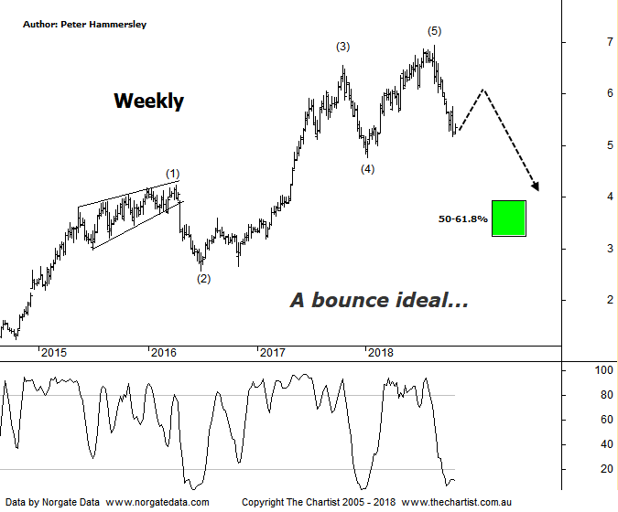

Bottom Line
30/10:
Daily Trend: Down
WeeklyTrend: Down
Monthly Trend: Down
Support levels: $4.77 - $4.55
Resistance levels: $6.92
Video Analysis
Watch Video Analysis Here
Technical Discussion
Qantas Airways is involved in the operation of international and domestic air transportation services, the provision of freight services and the operation of a Frequent Flyer loyalty program. The Company’s main business is the transportation of customers using two complementary airline brands which are Qantas and Jetstar. It also controls subsidiary businesses including other airlines and businesses in specialist markets, such as Q Catering. The Company operates in four sections; Qantas Domestic, Qantas International, Qantas Loyalty and Qantas Freight. For the year ending the 30th of June 2018 revenues increased 6% to A$17.06B. Net income increased 15% to A$980M. Revenues highlight the Qantas International section increase of 28% to A$6.52B and the Australia section increase of 6% to A$11.19B. Broker consensus is “Buy”. The dividend yield is 2.6%.
Reasons to be cautious:
→ Impulsive price action lower commenced.
→ Trading conditions deteriorating.
→ High free cash flow should continue on the back of a favourable domestic market position and the repositioning of the international business.
→ A $332m buyback is forecast for the second half with the potential for more at the → FY19 results.
→ Trading at a discount to its peers.
→ Transformation benefits could offset non-fuel cost inflation.
→ Discipline in the domestic market should result in higher margins and offset high fuel costs and international competition.
→ Applying to extend its partnership with Emirates for another five years which is critical to profitability.
→ Lower fuel costs improve profitability.
→ Cost cutting measures are continuing.
Price was approaching our target area either side of $5.60 during our last review meaning buyers needed to appear quickly to keep the strong uptrend in motion. Not to be, with our target zone being overcome in a straight-line movement which is something that’s been transpiring on many charts for several weeks now. With the smaller degree patterns deteriorating and lacking clarity we are going to take a big step back and concentrate on the weekly chart. It is feasible that a completed 5-wave move has terminated which commenced all the way back in late 2013. It’s been a stellar ride higher although as always, every trend needs to see a decent pause or correction which ideally is what’s transpiring now. Unless QAN can get up through the pivot high at $6.92 the risk is that price is going to eventually travel down to the 50% - 61.8% retracement zone as annotated sitting between $3.93 - $3.24 which is obviously a substantial percentage fall from current levels. It is early days although that lower target area certainly isn’t off the table. It’s not going to be a straight-line movement down despite the potency of leg South over the past few weeks. Like many companies, it is looking oversold over the short-term meaning a bounce wouldn’t go amiss. Adding weight to the case for a rally is bullish divergence on the daily chart (not shown) with price making a lower low whilst our oscillator has failed to confirm that weakness by making a higher low. It’s yet to trigger, although if it does then a bounce will almost certainly unfold although at this stage that’s all we’ll be looking for - a rally only.
Trading Strategy
It’s a similar situation in many stocks we cover in that we need to see a bounce before looking for short set-ups. As stated in Friday’s review of the XJO, the patterns were advocating a rally and thus far it appears to be unfolding despite it being early days. As long as rallies are choppy and messy in nature suggesting they are corrective then opportunities will arise. If the wave count is correct there is plenty of downside to come, albeit following a bounce over the coming weeks.

