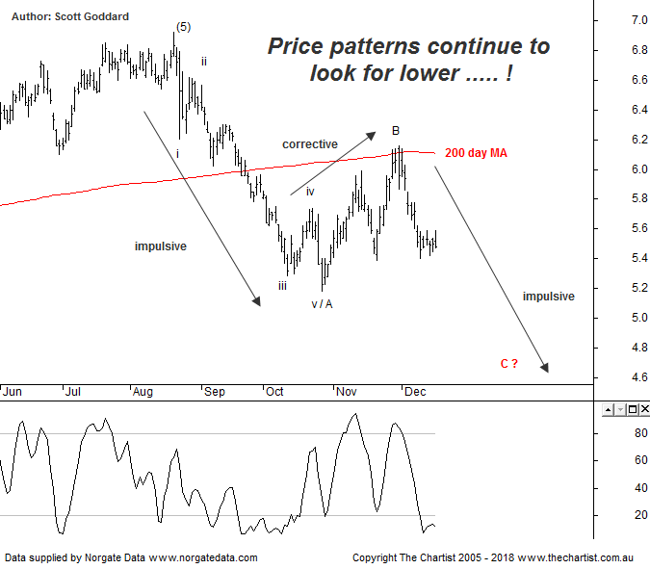

Bottom Line
18/12:
Daily Trend: Down
WeeklyTrend: Down
Monthly Trend: Down
Support levels: $5.18 / $4.77 - $4.55
Resistance levels: $6.16 / $6.92
Video Analysis
Watch Video Analysis Here
Technical Discussion
Qantas Airways is involved in the operation of international and domestic air transportation services, the provision of freight services and the operation of a Frequent Flyer loyalty program. The Company’s main business is the transportation of customers using two complementary airline brands which are Qantas and Jetstar. It also controls subsidiary businesses including other airlines and businesses in specialist markets, such as Q Catering. The Company operates in four sections; Qantas Domestic, Qantas International, Qantas Loyalty and Qantas Freight. For the year ending the 30th of June 2018 revenues increased 6% to A$17.06B. Net income increased 15% to A$980M. Revenues highlight the Qantas International section increase of 28% to A$6.52B and the Australia section increase of 6% to A$11.19B. Broker consensus is “Buy”. The dividend yield is 2.4%.
Reasons to be cautious:
→ Impulsive price action lower commenced.
→ Trading conditions deteriorating.
→ High free cash flow should continue on the back of a favourable domestic market position and the repositioning of the international business.
→ A $332m buyback is forecast for the second half with the potential for more atthe FY19 results.
→ Trading at a discount to its peers.
→ Transformation benefits could offset non-fuel cost inflation.
→ Discipline in the domestic market should result in higher margins and offset high fuel costs and international competition.
→ Applying to extend its partnership with Emirates for another five years which is critical to profitability.
→ Lower fuel costs improve profitability.
→ Cost cutting measures are continuing.
'The leg down from the high of wave-(5) subdivides into a 5-wave move meaning a corrective pattern higher should take price into the typical retracement zone .... price would need to head up through the 61.8% level at $6.26 to suggest the deeper retracement can be avoided.' Well it is clear now that a deeper pullback is back to being front and center. The 5-wave move south where we have locked in the Wave-A was proceeded by a symmetrical a-b-c counter trend move which landed right in the pocket of the 50.0% - 61.8% pull back zone circa $6.16. From here price has rejected pretty much right on cue, with the scene now set for it to complete this corrective move as an A-B-C zig zag type pattern. Wave equality targets $4.42 with the 50.0% - 61.8% pullback zone aligned to $4.00 - $3.50. The 200 day moving average was also influential in rejecting price recently, and if this is a downside Wave-C move now in motion, it could well be a very swift process as Wave-C's and Wave-3's have similar characteristics in that they are impulsive and powerful in the direction of the trend. So some more pain to come by the looks of it unless levels can suddenly reverse and break past $6.16 with conviction. Time to let price action lead the way.
Trading Strategy
'If you are aggressive and looking for shorting opportunities, then it’s worth keeping an eye on the typical retracement zone as shown. Clear rejection in that area would provide a low risk entry.' Even though no formal recommendation was provided by Pete, if you did short Qantas on his advice, the entry would have been at $5.85 with stops at $6.16. Trail the stop lower if things start to further deteriorate from here. On the flip side if this overall move does only prove to be A-B-C in nature, then buying opportunities may start to come into play within our aforementioned $3.50 - $4.50 target price zone. We will keep an eye on it.

