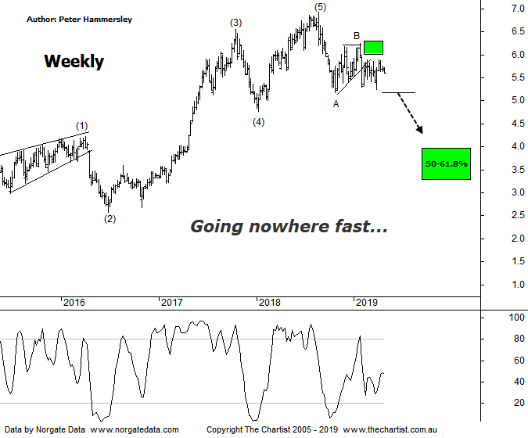

Bottom Line
23/4:
Daily Trend: Down
WeeklyTrend: Down
Monthly Trend: Down
Support levels: $5.18 / $4.77 - $4.55
Resistance levels: $6.23 / $6.92
Video Analysis
Watch Video Analysis Here
Technical Discussion
Qantas Airways is involved in the operation of international and domestic air transportation services, the provision of freight services and the operation of a Frequent Flyer loyalty program. The Company’s main business is the transportation of customers using two complementary airline brands which are Qantas and Jetstar. It also controls subsidiary businesses including other airlines and businesses in specialist markets, such as Q Catering. The Company operates in four sections; Qantas Domestic, Qantas International, Qantas Loyalty and Qantas Freight. For the six months ending the 31st of December 2018 revenues increased 6% to A$9.21B. Net income decreased 16% to A$498M. Revenues highlight the Qantas International section increase of 7% to A$3.49B, the Australia section increase of 5% to A$6.18B and the revenue Passengers-Qantas Inter increase of 6% to 4.4M. Net income was offset by EBITDAR decrease of 6% to A$1.82B. Broker consensus is “Buy”. The dividend yield is 3.0%.
Reasons to be cautious:
→ Impulsive price action lower commenced.
→ Trading conditions deteriorating.
→ Operating headwinds remain.
→ At risk from the current bounce in oil prices.
→ Earnings and cash flow set to decline.
→ Buy-back and solid dividend recently announced.
→ High free cash flow should continue on the back of a favourable domestic market position and the repositioning of the international business.
→ Trading at a discount to its peers.
→ Cost cutting measures are continuing.
→ Larger degree patterns under pressure.
We must go all the way back to late February to find our last review of Qantas although we have been concentrating on the weekly chart of late. There is no reason to deviate from this stance with the larger degree patterns continuing to show more clarity. Last time price had broken through the lower boundary of an ascending triangle which set the stage for lower prices. However, this hasn’t transpired with price instead tracking sideways over the past few weeks in lacklustre fashion. Normally when price breaks through the upper or lower boundary of a triangle we expect to see strong impulsive price action although this guideline has been ignored in this instance. It doesn’t negate the possibility of seeing lower prices although the downside break out of the consolidation phase hasn’t stuck which is reason to be cautious. Price would need to break through the prior pivot low at $5.25 to suggest the typical retracement zone as annotated sitting either side of $3.50 is going to be tagged further down the track. That’s a hefty percentage decline from current levels although from an Elliott perspective it’s still feasible. The reason being, we have a clear 5-wave move higher which terminated in August of last year. Not only that, but price impulsed down to wave-A which is a strong indication that it’s only part of a larger corrective pattern. A push above the high of wave-B and the 61.8% retracement level around $6.30 would be required before thinking in terms of avoiding the deeper retracement. Even then, it’s highly likely that a larger consolidation pattern is going to unfold as opposed to seeing a resumption of the exceptional multi-year uptrend.
Trading Strategy
Price has been meandering sideways for several weeks meaning clarity is lacking from an Elliott perspective. The problem with lacklustre price action is that it can often continue for much longer than anticipated which could turn out to be the case here. As such, we’ll continue to stand aside until price makes a decisive break one way or the other.

