Rio Tinto Ltd (RIO)
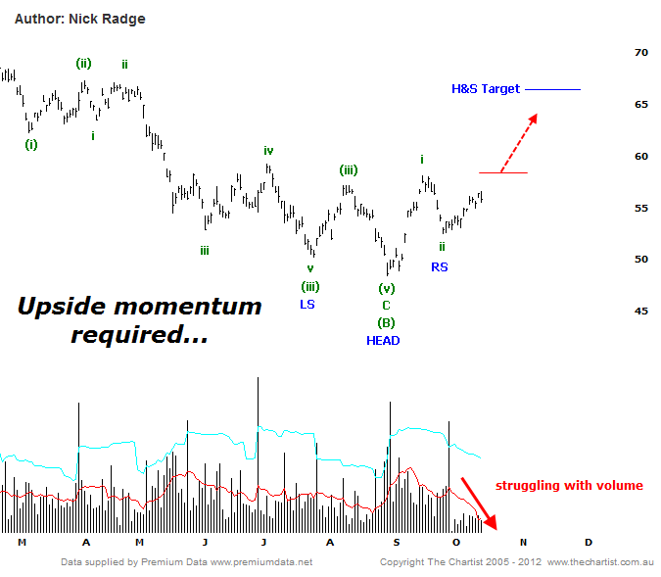
Bottom Line
15/10:
EW Trend: Corrective(?)
Price Trend: Down
Trend Strength: Weak
Video Analysis Watch Video Analysis Technical Discussion
15/10:
LAYMANS:
It's been a month since our last review (see archives below) and back then we liked the look of RIO but suggested it was over extended in the near term with a dip back to $52.00 to $53.00 warranted. Prices did indeed dip and tagged a low of $52.51 on September 26th. We also mentioned back then that the stock has enormous upside potential if our analysis is proven correct. There remains a risk however that we could see further sideways consolidation. Ideally ongoing strength, like we've seen in recent weeks, and upside persistence through $58.00 would solidify the wanted bullish argument and negate concerns of further sideways action. If we do see ongoing range bound trading, the bullish argument remains valid but the move will be extended in terms of time. A decline back through recent lows at $52.51 would not be positive for momentum and should read as a red flag suggestive of further consolidation in the near term. A break down through $48.30 invalidates the bullish argument and would require reassessment of the technical picture.

TECHNICAL:
The dip into the typical retracement zone suggests wave-ii is complete and in theory wave-iii, the strongest wave, is now underway. It also suggests the right shoulder of the reverse Head & Shoulders pattern has completed, although as yet confirmation by penetration of the neckline is yet to occur. And this is basically the crux of the current trend position of RIO; the stock needs to make a statement and break through $58.00 to give us an unquestionably bullish trend. The issue I have now is that volume has been extremely light over the last week or so. Ideally it should be higher. A low volume decline is great news, but a low volume advance is not so credible. It may well be that we're seeing the first signs of a broader congestion, so the inability to break $58.00 in the coming few weeks will suggest further base building is unfolding. If we do get the break there are several upside targets to consider. Firstly, the wave equality point is $62.00 which is seen has a very high probability level. However, if we're in the wanted impulse we should zip through that level without hesitation. The second target is the Head & Shoulders measured move at $66.00. Lastly, the completion of a fully formed 5-wave advance suggested $75.00 which aligns with significant resistance set in 2011/12. Ultimately $105 to $110 is at the far end of the scale when looking at weekly time frames, but first and foremost we need to get up and through $58.00.
Trading Strategy
15/10:
If you purchased RIO on the recent dip then continue to hold. I would even suggest adding to existing positions on penetration of $58.00. If you're standing back at this juncture, then the same action would be recommended on break of $58.00. A more aggressive stance is to initiate new partial positions here, then add on the break higher. Ideally we don't wish to see recent lows below wave-ii breached, so place protective stops at $52.50 or below. If you're happy to allow some wiggle room, then stops should be placed below $48.30.

