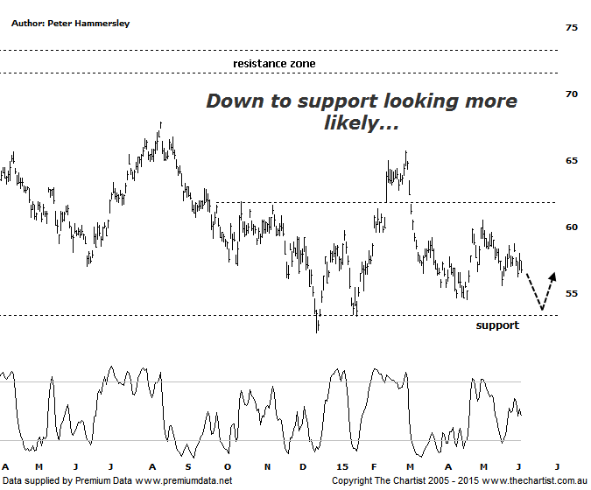

Bottom Line
4/6:
Daily Trend: Neutral
Weekly Trend: Down
Monthly Trend: Down
Support levels: $54.52 / $52.00
Resistance levels: $60.50 / $65.73
Video Analysis
Watch Video Analysis Here
Technical Discussion
Rio Tinto is involved in finding, mining and processing mineral resources. The Company’s products include aluminium, copper, diamonds and minerals, energy and iron ore. In January 2012, it acquired 2% of Ivanhoe Mines Ltd. In August 2012, Orocobre Ltd acquired Borax Argentina S.A. from Rio Tinto Ltd entities, Rio Tinto Minerals Development Limited and Borax Europe Limited. In September 2012, it sold the North American portion of its Alcan Cable business to General Cable Corporation. This month Rio completed the sale of its 50.1% interest in the Clermont Joint Venture to GS Coal Pty Ltd. For the fiscal year ending the 31st of December 2014 revenues decreased 7% to $47.66B. Net income increased 78% to $6.53B. Revenues echo the Iron Ore segment decrease of 10% to $23.28B. Broker consensus is currently “Hold”. The dividend yield is 4.8%.
Reasons to be more optimistic longer term (downside risk short term):
Bauxite prices have remained resilient whilst many other bulk commodity prices have been weak.
Support should be forthcoming due to the US$2bn buy-back and attractive dividend yield.
Further cost-cutting and reduced debt is looking more likely.
There is continued expectation of higher capital returns.
Upside remains due to increased production in Pilbara, Escondida and Oyu Tolgoi.
The Aluminium division has been restructured and could contribute significantly to earnings in coming years.
We took a look at the weekly chart of RIO last time which showed a large trading range that commenced all the way back in 2011. Our highest expectation was for price to head down to the lower boundary of that range circa $50.00. In actual fact the company itself has shown some decent resilience over the past few weeks whilst the banks have been embarking on a deeper corrective phase. However, the door is still open to head down toward the aforementioned deeper target although something more sinister isn’t anticipated, despite market conditions deteriorating over more recent times. The only glimmer of hope for the bulls over the short term is that price can push up through the recent pivot high at $60.50 but although not impossible it just seems like a hurdle too far at this stage of proceedings. The one positive on the chart is that volume has been steadily declining since the interim top was made on the 5th of May. This tells us that the smart money isn’t exiting positions and as long as this characteristic continues there is every chance that they will re-enter, especially if price does head down toward the lower boundary of the trading range as previously mentioned. We’ve been noting recently that the Materials sector has been showing much more resilience of late and looking at the longer term charts of the likes of RIO and BHP implies this trait has a good chance of continuing although this conclusion isn’t set in stone. The smaller degree patterns still need to prove themselves.
Trading Strategy
Trying to get involved with a stock when the chart is looking extremely messy (as it is here) is risky meaning it’s something we are not going to contemplate. There are two scenarios where we’ll start to take an interest. The first is if price heads down toward the minor line of support circa $54.00 with buyers returning in numbers. The second reason to be looking for a swing trade higher would arise if the recent pivot high at $58.77 is penetrated although some patience is going to be required before either scenario traces out. We’ll be looking for the more bullish picture to unfold as a rotation down toward the minor line of support keeps the door open for the lower boundary of the large trading range (better viewed on the weekly time frame) to be the next port of call.

