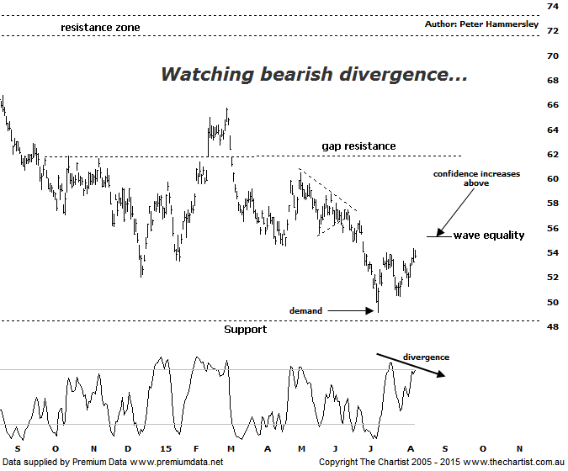

Bottom Line
10/8:
Daily Trend: Up
Weekly Trend: Down
Monthly Trend: Down
Support levels: $49.13 / $48.37
Resistance levels: $55.30 / $58.31/ $60.50
Video Analysis
Watch Video Analysis Here
Technical Discussion
Rio Tinto is involved in finding, mining and processing mineral resources. The Company’s products include aluminium, copper, diamonds and minerals, energy and iron ore. In January 2012, it acquired 2% of Ivanhoe Mines Ltd. In August 2012, Orocobre Ltd acquired Borax Argentina S.A. from Rio Tinto Ltd entities, Rio Tinto Minerals Development Limited and Borax Europe Limited. In September 2012, it sold the North American portion of its Alcan Cable business to General Cable Corporation. Last month Rio completed the sale of its 50.1% interest in the Clermont Joint Venture to GS Coal Pty Ltd. For the six months ending the 30th of June 2015 revenues decreased 26% to $17.98B. Net income decreased 82% to $806M. Revenues reflect the Iron Ore segment decrease of 40% to $7.57B. Broker consensus is currently “Hold”. The dividend yield is 5.5%.
Reasons to be more optimistic longer term (downside risk short term):
→ Progress has been made in reducing capex.
→ Bauxite prices have remained resilient whilst many other bulk commodity prices have been weak.
→ Support should be forthcoming due to the US$2bn buy-back and attractive dividend yield.
→ There is continued expectation of higher capital returns.
→ Upside remains due to increased production in Pilbara, Escondida and Oyu Tolgoi.
→ The Aluminium division has been restructured and could contribute significantly to earnings in coming years.
One interesting aspect of the big Miners is the dividend yield which continues to look attractive on the face of it. The main question of course is whether companies like RIO and BHP are going to be able to service the current yield. We’ll concentrate on RIO as recent results have provided a clue. It appears that cash flow was generally better than expected and with reductions in capex it could well be that the current dividend policy is going to be maintained. This is by no means set in stone but reading between the lines means there is hope. From a technical perspective it was very important that the line of support just beneath $50.00 held following our last review which I am pleased to say has proven to be the way forward with buyers stepping up to around those slightly lower levels. In fact it’s been a decent bounce over the past few weeks with recent results doing nothing to dampen the enthusiasm. Whether the recent show of resilience is sustainable is the million dollar question although it is interesting that Type-A bearish divergence is in position. However, it hasn’t yet triggered meaning it’s something to watch only at this stage. One level we need to keep a close eye on is $55.30 which is the wave equality projection of the movement higher that commenced on the 9th of July. Rejection at those slightly higher levels would be reason for concern and portend another leg lower. A break up through that aforementioned level would open the door for a continuation up toward $58.30 as a minimum with even further upside potential ahead.
Trading Strategy
From a pure trading point of view there is a possibility of a shorting opportunity presenting itself over the coming days though it’s going to be dependent on the wave equality projection mentioned above at $55.30 being tagged and rejected. Should this transpire nimble traders could short-sell though I wouldn’t get overly excited in regard to downside potential as the zone of support is solid and all things being equal should not be exceeded. On the flip side, if price gets up through the wave equality projection we start to look for buying opportunities.

