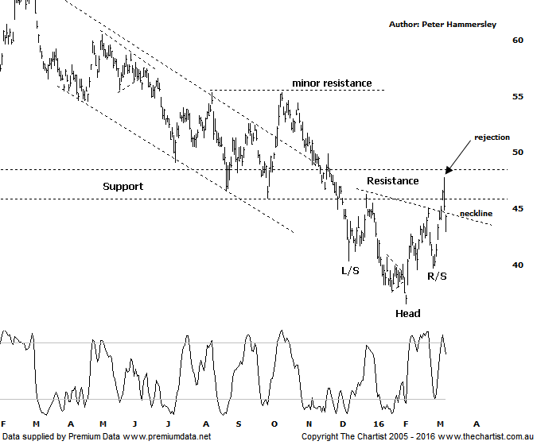

Bottom Line
9/3:
Daily Trend: Up
Weekly Trend: Up
Monthly Trend: Down
Support levels: $36.53 / $27.22 / $23.59
Resistance levels: $47.80 / $55.34 / $72.30
Video Analysis
Watch Video Analysis Here
Technical Discussion
Rio Tinto is involved in finding, mining and processing mineral resources. The Company’s products include aluminium, copper, diamonds and minerals, energy and iron ore. In January 2012, it acquired 2% of Ivanhoe Mines Ltd. In August 2012, Orocobre Ltd acquired Borax Argentina S.A. from Rio Tinto Ltd entities, Rio Tinto Minerals Development Limited and Borax Europe Limited. In September 2012, it sold the North American portion of its Alcan Cable business to General Cable Corporation. Last month Rio completed the sale of its 50.1% interest in the Clermont Joint Venture to GS Coal Pty Ltd. For the year ending the 31st of December 2015 revenues decreased 27% to $34.83B. Net loss totaled $866M against income of $6.53B. Revenues reveal a decrease in demand for the Company's products and services due to unfavorable market conditions. Broker consensus is currently “Hold”. The dividend yield is 6.4%.

Reasons to be more optimistic longer term:
→ A 10% increase in iron ore and 34% increase in coal reserves has been announced.
→ Strong cash flow continues.
→ Progress has been made in reducing capex.
→ Support should be forthcoming due to the US$2bn buy-back and attractive dividend yield.
→ There is continued expectation of higher capital returns.
→ Upside remains due to increased production in Pilbara, Escondida and Oyu Tolgoi.
→ The Aluminium division has been restructured and could contribute significantly to earnings in coming years.

There were a couple of patterns to take a look at during our last look at Rio, the significant one being a possible H&S although it was still early days with price needing to prove itself. That’s exactly what it’s done and in terms of the pattern we really couldn’t have asked for too much more. The right shoulder has now been formed with impulsive price action pushing up through the neckline of the pattern. That’s the good news. Not quite so positive is the clear rejection from the zone of resistance witnessed yesterday. Normally we like to see the neckline revisited but certainly not breached in such a manner as that seen today. The one positive during today’s session was the close off the session’s lows although it’s difficult to be to bullish having seen a 3% decline. One thing is for sure, if the H&S pattern is going to prove its worth then buyers need to step up to the plate immediately. A break down through the R/S at $39.74 invalidates the reversal pattern and puts the risk back to the downside. For the moment though the tentative bullish case remains alive but impulsive price action higher needs to kick in again, realistically by the end of this week. Many brokers and analysts have been becoming much more bullish on the likes of Rio and BHP, no doubt partly due to the rally in commodity prices. Iron ore for example has rallied strongly over recent times though we have to keep our feet firmly on the ground when taking a look at the potency of the prior downtrend. The Materials sector has been outperforming the banks recently though it’s still too early to be getting overly optimistic longer term.
Trading Strategy
It’s interesting that volume has started to increase off the pivot low made in early February which is exactly what we look for when trying to project a potential reversal point. Nothing is guaranteed of course though small steps in the right direction are being taken which is all we can ask for. If you want to be involved here then wait until yesterday’s high at $47.80 is overcome before jumping on. The measured move out of the H&S comes in at $55.00 which coincidentally aligns with the next minor line of resistance as annotated. We can be aggressive with the initial stop placing it just beneath the neckline at $42.99. The risk/reward isn’t sufficient to make a formal recommendation though it’s a high probability target area if some traction can be gleaned.

