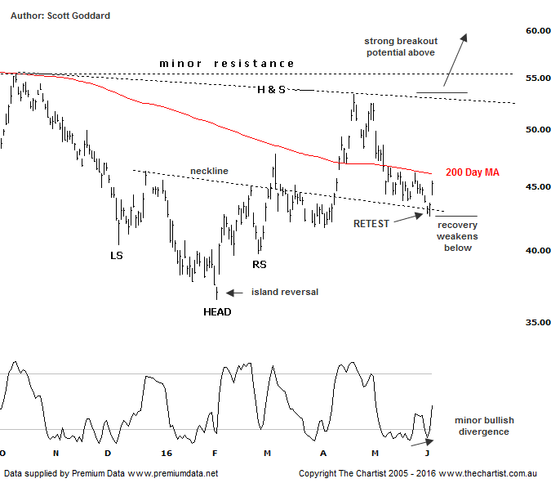
Bottom Line
6/6:
Daily Trend: Up
Weekly Trend: Neutral
Monthly Trend: Down
Support levels: $41.73 / $39.60 / $36.53
Resistance levels: $55.34 / $60.50 / $65.73
Video Analysis
Watch Video Analysis Here
Technical Discussion
Rio Tinto is involved in finding, mining and processing mineral resources. The Company’s products include aluminium, copper, diamonds and minerals, energy and iron ore. In January 2012, it acquired 2% of Ivanhoe Mines Ltd. In August 2012, Orocobre Ltd acquired Borax Argentina S.A. from Rio Tinto Ltd entities, Rio Tinto Minerals Development Limited and Borax Europe Limited. In September 2012, it sold the North American portion of its Alcan Cable business to General Cable Corporation. Last month Rio completed the sale of its 50.1% interest in the Clermont Joint Venture to GS Coal Pty Ltd. For the year ending the 31st of December 2015 revenues decreased 27% to $34.83B. Net loss totaled $866M against income of $6.53B. Revenues reveal a decrease in demand for the Company's products and services due to unfavorable market conditions. Broker consensus is currently “Hold”. The dividend yield is 5.4%.
Reasons to be more optimistic longer term:
→ A 10% increase in iron ore and 34% increase in coal reserves has been announced.
→ Strong cash flow continues.
→ Progress has been made in reducing capex.
→ Support should be forthcoming due to the US$2bn buy-back and attractive dividend yield.
→ There is continued expectation of higher capital returns.
→ Upside remains due to increased production in Pilbara, Escondida and Oyu Tolgoi.
→ The Aluminium division has been restructured and could contribute significantly to earnings in coming years.
A good day for Iron Ore Producers today with RIO, BHP and FMG all up over 3.5% and clearly revealing their direct correlation to the Iron Ore Chart, with the metal bouncing higher in its last trading session off the recent 47.90 lows. This low point though is about as deep as we wish price to head with it being only slightly below our key retracement price point, and finding significant buyer support off a now fully unwound weekly bearish divergence indicator. If 47.90 can hold from here then there is scope for price to swing higher eventually which is going to keep levels in stocks like RIO nice and robust moving forward. So the head and shoulders pattern that Pete was tracking off the island reversal low circa $36.53, now has the potential of being labelled a significant low. And with the head and shoulders pattern target all but achieved circa $53.63, our interest is now on the immediate retest of the original neckline break from three sessions ago at $42.57. Basically any price move below here puts a big question mark on RIO's overall recovery attempts. So the scenario from here is for some further coiling over the next couple of months, yet with the next significant move being strong and to the upside. Pete may even look at the larger bullish reverse and shoulders pattern on the weekly charts at next review, if price continues to hold strong from here.

Trading Strategy
If the robust price patterns can hold up, then a solid trading opportunity on the long side is what we will be on the look our for, more than likely above $53.35. Such a move could easily take price back up towards the $70.00 price zone so not bad work if we can get it. Stay patient til then.

