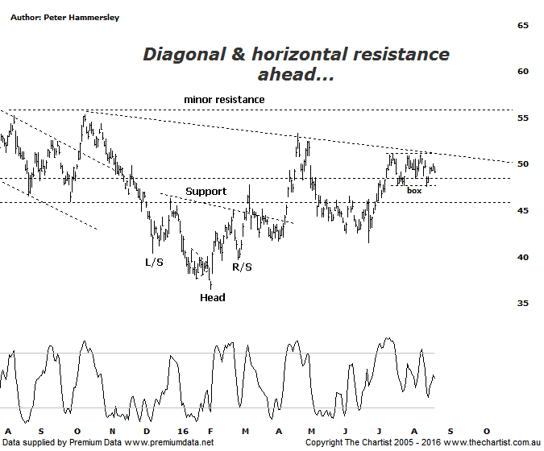

Bottom Line
22/8:
Daily Trend: Neutral
Weekly Trend: Up
Monthly Trend: Up
Support levels: $46.25 - $45.15 /$41.51
Resistance levels: $53.35 / $55.34 / $60.50 / $65.73
Video Analysis
Watch Video Analysis Here
Technical Discussion
Rio Tinto is involved in finding, mining and processing mineral resources. The Company’s products include aluminium, copper, diamonds and minerals, energy and iron ore. In January 2012, it acquired 2% of Ivanhoe Mines Ltd. In August 2012, Orocobre Ltd acquired Borax Argentina S.A. from Rio Tinto Ltd entities, Rio Tinto Minerals Development Limited and Borax Europe Limited. In September 2012, it sold the North American portion of its Alcan Cable business to General Cable Corporation. Last month Rio completed the sale of its 50.1% interest in the Clermont Joint Venture to GS Coal Pty Ltd. For the year ending the 31st of December 2015 revenues decreased 27% to $34.83B. Net loss totaled $866M against income of $6.53B. Revenues reveal a decrease in demand for the Company's products and services due to unfavorable market conditions. Broker consensus is currently “Hold”. The dividend yield is 5.6%.
Reasons to be more optimistic longer term:
→ A 10% increase in iron ore and 34% increase in coal reserves has been announced.
→ Strong cash flow continues.
→ Progress has been made in reducing capex.
→ Support should be forthcoming due to the US$2bn buy-back and attractive dividend yield.
→ There is continued expectation of higher capital returns.
→ Upside remains due to increased production in Pilbara, Escondida and Oyu Tolgoi.
→ The Aluminium division has been restructured and could contribute significantly to earnings in coming years.

It’s been difficult to want to get involved in either BHP or RIO for a substantial period of time now although the patterns have been looking a little better more recently. A decent bounce has unfolded from the 24th of June low culminating in a gain of around 20% to today’s high. In fact, the miners have been looking better this year which is evidenced by the outperformance of the Materials sector, especially when compared to the banks. But is this outperformance going to result in a more substantial and impulsive rally from RIO? What we can say is that the company is looking better than it has for some time with the recent consolidation within the box pattern offering scope for an upside breakout. At the moment though, price is sitting right smack bang in the middle of the consolidation pattern which means some patience is likely going to be required. There is also the diagonal line of resistance to contend with although we prefer to concentrate on the horizontal variety. With this in mind, we also have to be cognizant of the minor area of resistance around $55.00 which all in all means that there are still headwinds to overcome before getting overly excited. For now though, small steps in the right direction are being taken and with the broader market looking better than it has for several years there is the potential to see something more bullish unfold over the medium to longer term. A break down through the lower boundary of the box pattern portends a continuation down toward the typical retracement zone sitting between $46.27 - $45.15 which could also present a buying opportunity a little further down the track.
Trading Strategy
As mentioned above, we’ve had to be patient with the big miners, especially when the recent leg higher in the broader market has triggered some decent trends in the second and third tier stocks. If you want to be involved here, then wait until the upper boundary of the box at $51.04 has been overcome before initiating long positions. Place the initial stop at $47.61 which provides a low risk entry. A trailing stop will need to be used to manage the position with no high probability target area presenting itself at this time. There is no formal recommendation but we’ll continue to keep a close eye on both RIO & BHP for opportunities.

