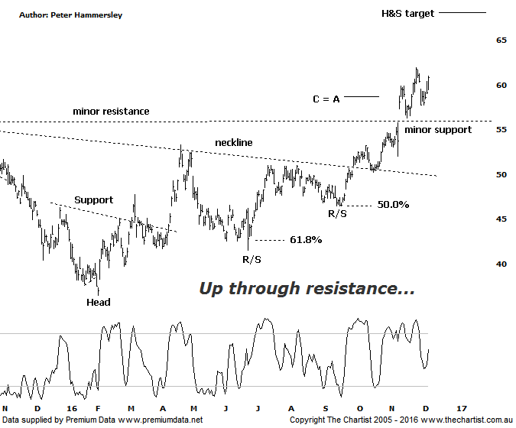

Bottom Line
7/12:
Daily Trend: Neutral
Weekly Trend: Up
Monthly Trend: Up
Support levels: $55.78 - $53.35 / $50.27
Resistance levels: $65.73 / $71.04 - $72.30
Video Analysis
Watch Video Analysis Here
Technical Discussion
Rio Tinto is involved in finding, mining and processing mineral resources. The Company’s products include aluminium, copper, diamonds and minerals, energy and iron ore. In January 2012, it acquired 2% of Ivanhoe Mines Ltd. In August 2012, Orocobre Ltd acquired Borax Argentina S.A. from Rio Tinto Ltd entities, Rio Tinto Minerals Development Limited and Borax Europe Limited. In September 2012, it sold the North American portion of its Alcan Cable business to General Cable Corporation. Last month Rio completed the sale of its 50.1% interest in the Clermont Joint Venture to GS Coal Pty Ltd. For the six months ending the 30th of June 2016 revenues decreased 14% to $15.5B. Net income increased from $806M to $1.71B. Revenues echo a decrease in demand for the Company's products and services due to unfavorable market conditions. Broker consensus is currently “Hold”. The dividend yield is 4.9%.
Reasons to be more optimistic longer term:
→ Potential for a lift in the dividend payout.
→ A US$2bn buy-back looking likely next year.
→ FY17 forecasts for coking and thermal coal have been increased by around 20%.
→ Recently updated commodity prices bode well.
→ A 10% increase in iron ore and 34% increase in coal reserves has been announced.
→ Progress has been made in reducing capex.
Price was hovering around a minor line of resistance during our last review with the ideal situation being to break up through that region and on toward our target area sitting at $58.33. It was going to take a push above that initial target before thinking in terms of something more bullish unfolding medium to longer term. In that regard we couldn’t have asked for anything more with price continuing to head higher over the past few weeks. Commodity prices have remained hot over more recent times which has been helping along the likes of RIO, BHP & S32. With Donald now in charge (Trump), this trait should continue for the foreseeable future, although a pause for breath wouldn’t go amiss. The patterns are quite choppy and messy off the February lows made this year although this in itself isn’t reason for concern. Overlapping wave structures go hand-in-hand with this stock and it certainly doesn’t detract from the upside potential that remains. From an Elliott Wave perspective, there isn’t a great deal to work with so we’ll concentrate on the clarity that the complex H&S pattern brings. We took a look at this a few weeks ago, although continued strength means we now have the target out of that pattern in our sights. There is now every expectation that $68.00 can be achieved although with a solid zone of resistance just above, between $70.00 - $72.00 price could continue up into that slightly higher zone. Let’s also remember that old resistance becomes new support meaning any retracement from here should be short-lived.
Trading Strategy
It could be argued that a small H&S reversal pattern is in play although it’s at much smaller degree and not overly significant as far as we are concerned. Even if it triggers price should only head to just beneath the minor line of support which wouldn’t be the end of the world. As long as any retracement is choppy and messy in nature it would present a buying opportunity, especially if price rejects hard from the line of support just above $55.00. If you are more aggressive you could jump on following a push above the recent pivot high at $61.94. Look to tighten the protective stop or even take profits between $68.00 - $72.00. There is no formal recommendation here though we’d like to be involved so it’s on the short-term watchlist.

