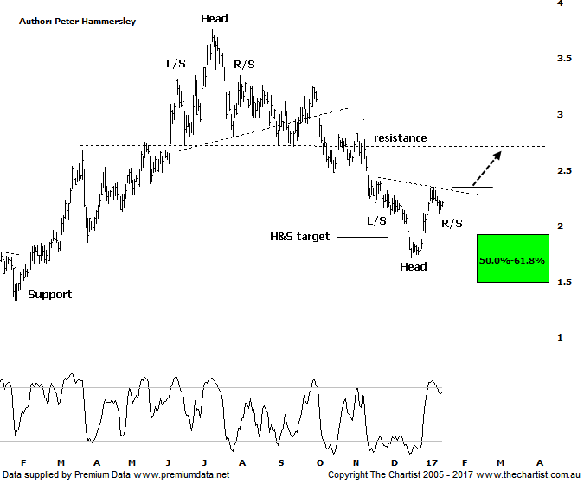

Bottom Line
17/1:
Daily Trend: Up
Weekly Trend: Down
Monthly Trend: Down
Support levels: $2.03 - $1.96 / $1.72
Resistance levels: $2.35 / $3.25 / $3.77
Video Analysis
Watch Video Analysis Here
Technical Discussion
St Barbara (SBM) is an Australia-based company involved in the mining and sale of gold, mineral exploration and development. The Company’s assets include the Leonora Operations in Western Australia, the Simberi mine in Papua New Guinea and the Gold Ridge mine in the Solomon Islands. As of September 30 2014 the Company produced 68,823 ounces of gold. For the year ending the 30th of June 2016 revenues increased 11% to A$612.1M. Net income before extraordinary items increased from A$21.2M to A$169.4M. Revenues reflect the Simberi section increase of 51% to A$169.8M and the Leonara section increase of 1% to A$440.3M. Broker/Analyst consensus is currently “Buy”. The company does not pay dividends.
Reasons to be more optimistic longer term:
→ Potential for capital management.
→ Gwalia cash generation from Gwalia maximised with mine life extended.
→ Marked improvement in operating performance.
→ September quarter production numbers were strong.
→ Debt now coming in at $18m compared to $311m two years ago.
→ Lifted reserves at Gwalia to 1.8m Oz’s.
→ Gold Ridge has been divested meaning the company can concentrate on its remaining assets.
We’ve mentioned several times over the past few weeks that fundamental analysts have become extremely bearish on gold for several reasons which we won’t go into again this evening. This is no doubting many of the gold related stocks we cover have embarked on significant retracements but most have only entered their respective typical retracement zones and target areas. SBM fits into that category. In fact, we were looking for price to come down to the Head & Shoulders target and the 50% - 61.8% retracement zone following our last review which is now a big box that can be ticked. Not only has price reversed from our target area but it’s done so in a strong impulsive manner, albeit at much smaller degree. Still, a small step in the right direction has been taken regarding a significant low being locked in. If this is the case though, impulsive price action needs to continue over the coming weeks. That said, there is room for short-term weakness taking SBM into the typical retracement zone of the short prior leg higher sitting between $2.03 - $1.96 although it isn’t a prerequisite to hit those lower levels before further strength kicks in. Zooming into the more recent price action also shows that an H&S pattern could be forming with weakness over the next few days likely completing the R/S. This would also be a bullish proposition, assuming the neckline of the pattern is penetrated. It would take a push beneath the recent pivot low at $1.72 to move us back to a neutral stance although a continuation beneath the 61.8% retracement level of the whole prior leg higher off the December 2014 lows to suggest all is not well.
Trading Strategy
As it stands right here and now it would take a push up through the diagonal line of resistance/neckline of the potential H&S pattern to initiate long positions. However, a rotation down toward $2.00 followed by signs of demand could provide a better entry point which is the strategy we’ll be taking. As such, the formal recommendation is to stand aside although SBM is on the short-term watchlist and may find its way into the Position Status Page shortly.

