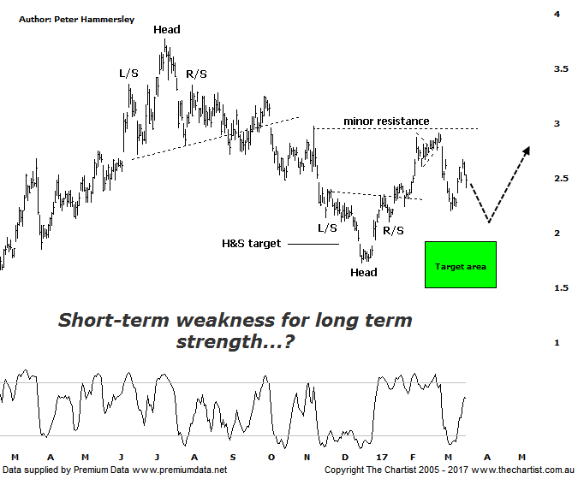

Bottom Line
20/3:
Daily Trend: Up
Weekly Trend: Up
Monthly Trend: Down
Support levels: $2.35 - $2.20 / $1.98 - $1.95
Resistance levels: $2.97 / $3.25 / $3.77
Video Analysis
Watch Video Analysis Here
Technical Discussion
St Barbara (SBM) is an Australia-based company involved in the mining and sale of gold, mineral exploration and development. The Company’s assets include the Leonora Operations in Western Australia, the Simberi mine in Papua New Guinea and the Gold Ridge mine in the Solomon Islands. As of September, 30 2014 the Company produced 68,823 ounces of gold. For the six months ending the 31st of December 2016 revenues increased 2% to A$320.6M. Net income increased 7% to A$82.6M. Revenues highlight the Leonara section increase of 2% to A$227.4M and the Simberi section increase of 4% to A$92.4M. Net income benefited from an interest expenses decrease of 61% to A$6.7M. Broker/Analyst consensus is currently “Buy”. The company does not pay dividends.
Reasons to be more optimistic longer term:
→ Balance sheet cleared with significant free cash flow.
→ Grade outperformance is expected to continue into big second half.
→ Potential for capital management.
→ Gwalia extension has been approved.
→ Now has corporate appeal.
→ Gold Ridge has been divested meaning the company can concentrate on its remaining assets.
Although price has rallied over the past couple of weeks there has been some damage inflicted to the smaller degree patterns on the back of the almost parabolic movement down from the high made on the 24th of February. We’d be pushing our luck to suggest it’s been a 3-wave movement even though the recent low terminated in the typical retracement zone of the whole prior leg higher. We also must take the time factor into account. It took around three months to head up to the recent pivot high with the subsequent retracement only taking seven trading days meaning symmetry hasn’t been met from a time perspective. Last Thursday’s high also hit the 61.8% retracement level of the prior leg down suggesting an interim top could well be in place. Should this be correct there is scope to head down toward the wave equality projection sitting at $1.955. This also aligns with the 78.6% retracement level which is occasionally tagged during deeper retracement’s. It wouldn’t be ideal to head to those lower levels as almost all the gains from this year will then have been eradicated, although it’s clearly a possibility. As always, much is going to depend on the price of gold though our stance remains the same; we are bullish medium to longer term though there is scope for short-term weakness. It would now take a comprehensive break up through the minor line of resistance around $3.00 to suggest the recent low is the full extent of the retracement although this isn’t looking likely at this stage. The risk for SBM is now to the downside despite continuing to look bullish longer term.
Trading Strategy
It would be an aggressive stance to want to trade the potential leg lower with the risk/reward not enticing enough for us to be involved. Should the deeper retracement unfold we’ll be looking for signs of demand returning around the area of confluence just beneath $2.00. It will still be prudent to sit this one out for the time being although ideally the next opportunity will be to the upside, albeit several weeks down the track and at lower levels.

