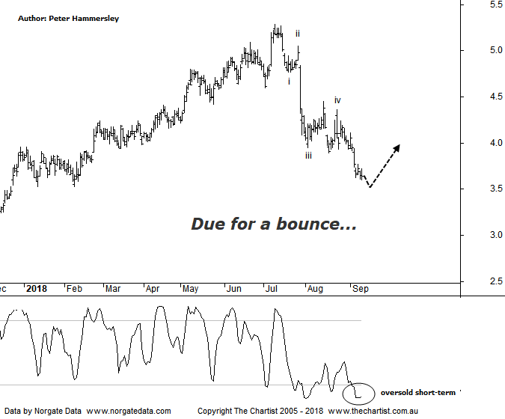

Bottom Line
11/9:
Daily Trend: Down
Weekly Trend: Down
Monthly Trend: Down
Support levels: $3.10 - $3.00 / $2.53 - $2.43
Resistance levels: $5.08 - $5.28
Video Analysis
Watch Video Analysis Here
Technical Discussion
St Barbara (SBM) is a gold producer and explorer. The Company is engaged in mining and the sale of gold, mineral exploration and development. Its sections include Leonora and Simberi. The Leonora Operations include the Gwalia approximately 1.2 million tons per annum (Mtpa) processing plant and the Gwalia Underground mine. The Company's Simberi mine is on Simberi Island in Papua New Guinea, which includes gold and porphyry copper-gold targets. The Simberi gold resources, reserves and mining operations are located in Mining Lease (ML) 136, which covers eastern half of Simberi Island, and the remainder of the island is covered by Exploration License (EL) 609, which also covers Tatau and Big Tabar Islands. For the year ending the 30th of June 2018 revenues increased 6% to A$684.5M. Net income increased 44% to A$227M. Revenues highlight the Leonara section increase of 4% to A$461.3M, the Simberi section increase of 9% to A$217.9M, the Australia Operation section increase of 4% to A$461.3M and the Pacific Operation section increase of 9% to A$217.9M. Broker/Analyst consensus is currently “Hold”. The dividend yield is 3.3%.
Reasons to be more optimistic longer term (caution medium term):
→ Operating cash flow is $315m with free cash of $232m.
→ Improved guidance for Simberi Sulphides.
→ An outstanding turnaround and growth story over the past few years.
→ Increased reserves though at Gwalia.
→ Gwalia producing strong free cash flow with excellent gold grades.
→ Grade outperformance is expected to continue.
→ Potential for capital management.
→ Now has corporate appeal.
→ Severely oversold over the short-term.
There’s no hiding the fact that the gold sector has taken a major hit here in Australia which is especially significant considering it had been showing strong resilience whilst gold itself was heading lower. SBM here has declined another 30% off the high made on the 10th of July. Not only has the yellow metal been a headwind but bearish divergence on the weekly chart (not shown) hasn’t been helping. The good news is that our oscillator on that timeframe is now deep into the oversold position meaning it’s no longer a hurdle. In fact, the company is looking severely oversold at current levels and it wouldn’t come as any great surprise to see a bounce over the next week or two. The corrective pattern lower we’ve been looking for hasn’t materialised, with strong impulsive price action taking hold over the past couple of months. From an Elliott perspective we’ll just concentrate on the more recent price action which shows that a 5-wave move lower has been underway. There is room for slightly lower levels although wave-v should be locked-in shortly. This would allow for a decent bounce, likely retracing between 50% - 61.8% of the whole leg down that commenced in early July. A strong 5-wave move lower shouldn’t complete the whole corrective pattern which is the reason we are looking for a countertrend movement higher only as opposed to something more bullish. Bigger picture, there is room for a deeper retracement which comes on the back of the exceptional trend that’s been unfolding over the years. In fact, back looking at the weekly chart shows the recent retracement is hardly making a dent into the longer-term uptrend. That’s the good news.
Trading Strategy
We haven’t wanted to be involved in the gold stocks recently which remains the case today, irrespective of the fact that many companies look to be severely oversold which is the case here. If you want to trade the anticipated bounce then lookout for either increasing volume coupled with high closes or some bullish divergence developing over the coming days as this would provide a low risk entry.

