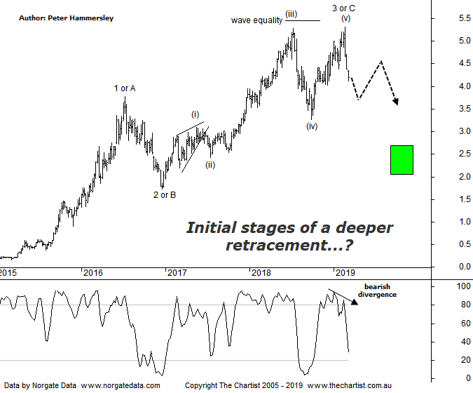

Bottom Line
6/3:
Daily Trend: Down
Weekly Trend: Down
Monthly Trend: Down
Support levels: $4.03 / $3.10 - $3.00 / $2.53 - $2.43
Resistance levels: $5.28 - $5.32
Video Analysis
Watch Video Analysis Here
Technical Discussion
St Barbara (SBM) is a gold producer and explorer. The Company is engaged in mining and the sale of gold, mineral exploration and development. Its sections include Leonora and Simberi. The Leonora Operations include the Gwalia approximately 1.2 million tons per annum (Mtpa) processing plant and the Gwalia Underground mine. The Company's Simberi mine is on Simberi Island in Papua New Guinea, which includes gold and porphyry copper-gold targets. The Simberi gold resources, reserves and mining operations are located in Mining Lease (ML) 136, which covers eastern half of Simberi Island, and the remainder of the island is covered by Exploration License (EL) 609, which also covers Tatau and Big Tabar Islands. For the six months ending the 31st of December 2018 revenues increased 1% to A$336.7M. Net income decreased 22% to A$82.6M. Revenues highlight the Simberi section increase of 16% to A$133.6M. Net income was offset by exploration expenses which increased 76% to A$7.5M and a net foreign exchange loss which increased from A$439K to A$2.9M. Dividend per share remained flat at A$0.04. Broker/Analyst consensus is currently “Hold”. The dividend yield is 2.9%.
Reasons to be more optimistic longer term (caution short - medium term):
→ A strong Gold price in Australian dollar terms.
→ Release of the feasibility study for the Leonora GMX a possible positive catalyst.
→ The balance sheet continues to strengthen.
→ In a strong position to progress opportunities.
→ The extension project at Gwalia appears to be on track.
→ An outstanding turnaround and growth story over the past few years.
→ Grade outperformance is expected to continue.
→ Potential for capital management.
→ Now has corporate appeal.
Our wave count was under pressure during the last review due to price heading up through the 50% - 61.8% retracement zone. On the daily chart clarity is still lacking so tonight we’ll zoom out to the weekly timeframe to reduce some of the noise. This shows that the recent pivot high completes either wave-3 or-C. The strong impulsive leg lower over the past three weeks or so suggests the latter is going to come to fruition although technically it would take a push beneath the 2016 high at $ 3.77 to cement the more bearish case. In reality, the writing is going to be on the wall well before those lower levels are tagged though. We must also remember that normally wave-3 in stocks is the extended leg which hasn’t been the way forward here. In fact, price even fell short of the wave equality projection, albeit by a small margin. We’ve also seen a completed 5-wave movement up to the recent pivot high, even though wave-(iv) was untypically deep. That said the guideline of alternation states that the two corrective moves should be completely different in nature which is the case here as wave-(ii) was shallow. Although we can’t discard the fundamentals of the company (which appear to be positive) much is going to depend on the price of gold which as we all know well by now has headed back down through the psychological US $1300 an ounce. Not surprisingly this has been the cause for the recent profit-taking in stocks such as SBM and EVN. The bottom line is, the yellow metal needs to reclaim US $1300 in a move that sticks before getting overly bullish.
Trading Strategy
We currently have exposure to gold via NCM, having recently taken profits on Evolution mining when the smaller degree patterns started to deteriorate. We will put setups forward within the sector when the patterns permit although now isn’t the time to be buying with your ears pinned back. If you haven’t taken a look at the Gold sub sector review (XGD) on Monday, it’s worth doing that now as a critical juncture has been met which should dictate where price heads over the coming weeks.

