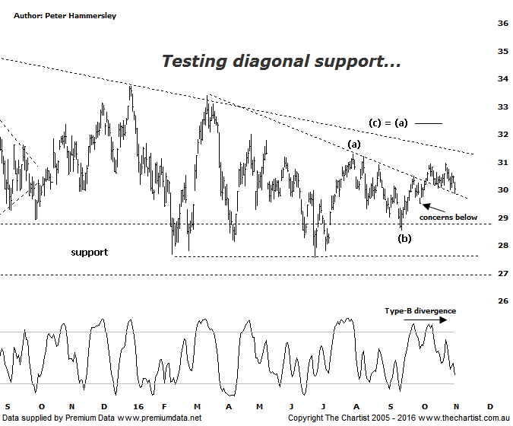

Bottom Line
2/11:
Daily Trend: Down
Weekly Trend: Neutral
Monthly Trend: Neutral
Support Levels: $28.56 / $27.57 - $27.02 / $23.99
Resistance Levels: $32.28 / $33.40 - $33.74 / $34.95
Video Analysis
Watch Video Analysis Here
Technical Discussion
Westpac is Australia's oldest banking group which operates throughout Australia and New Zealand. It is divided into three core businesses: Australian Financial Services, Institutional and New Zealand. Other brands it operates are St George, Bank of Melbourne, BankSA, RAMS and BT Financial Group. The recent period of NZ bank earnings outperformance over Australia is now coming to an end. NZ is coming off a cyclical peak of bad debt reduction analysts suggest the challenges ahead appear to be manageable. For the six months ending the 31st of March 2016 income decreased 3% to A$16B. Net interest income after loan loss provision increased 3% to A$6.81B. Net income applicable to common shareholders increased 3% to A$3.7B. The dividend yield is 6.2%. Broker consensus is currently “Hold”.
Reasons to be cautious:
→ FY results are reported next Monday (7th of November)
→ Has defensive qualities and is not exposed significantly to volatility in mining or NZ dairy.
→ A low risk profile coupled with cost discipline.
→ Offers attractive growth prospects and defensive qualities
→ High return on net tangible assets means its dividends face the least downside risk.
→ Defensively positioned loan book.
→ Banking sector valuations now considered at fair value.
Price is pretty much where we left it during our last review and although this isn’t ideal it keeps the door open to head up toward the line of diagonal resistance and even slightly higher toward the wave equality projection. The obvious headwind now is the state of the broader market with the mid and smaller cap stocks especially suffering some pain. Funnily enough the big miners have remained reasonably resilient, as have the big four banks. Whether this trait continues is going to depend on outside factors, noticeably the US election which is causing some minor panic. However, there is only another week to go before we have a result which is no doubt going to impact all markets one way or the other. That aside, we must run with the patterns as presented which in the case of Westpac are very choppy and messy to say the least. The bottom line is that price has been range bound since August 2015 with any trends being stopped in their tracks quickly. It’s difficult to envisage this trait changing any time soon without a catalyst coming out of left field. It would take a push beneath the recent pivot low at $ 27.57 to open the door for a deeper retracement although we believe it’s much more likely that price is going to continue to meander sideways and remain range-bound. Not ideal from a trading point of view although the one positive to come out of this type of price action is that the zone of support is continually attracting demand. At this stage, we can only retain a neutral stance though and expect more of the same - that is choppy patterns.
Trading Strategy
There is still a chance of hitting the diagonal line of resistance and even the wave equality projection slightly above $32.00 though at this stage is appears to be the full extent of any potential trend. As such we’ll refrain from making a recommendation as the reward simply isn’t worth the risk taken. On the flipside, a break down through the diagonal line of support, currently sitting just beneath the prior pivot low suggests a continuation down toward the $28.00 area which would be tradable if you’re more nimble and aggressive. For us, there is still every reason to stand aside.

Disclosure: Nick Radge holds

