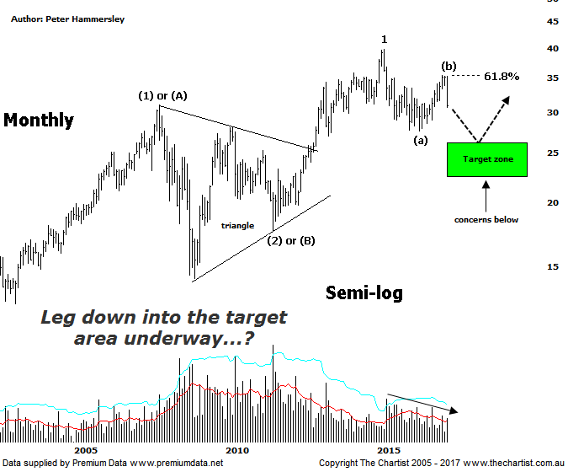

Bottom Line
19/5:
Daily Trend: Down
Weekly Trend: Down
Monthly Trend: Down
Support Levels: $31.48 - 30.55 / $27.57 - $26.92
Resistance Levels: $39.85
Video Analysis
Watch Video Analysis Here
Technical Discussion
Westpac is Australia's oldest banking group which operates throughout Australia and New Zealand. It is divided into three core businesses: Australian Financial Services, Institutional and New Zealand. Other brands it operates are St George, Bank of Melbourne, BankSA, RAMS and BT Financial Group. The recent period of NZ bank earnings outperformance over Australia is now coming to an end. NZ is coming off a cyclical peak of bad debt reduction analysts suggest the challenges ahead appear to be manageable. For the year ending the 30th of September 2016 interest income decreased 1% to A$31.82B. Net interest income after loan loss provision increased 4% to A$14.02B. Net income applicable to shareholders decreased 7% to A$7.44B. Net interest income after loan loss provision highlights the consumer bank section increase of 13% to A$6.68B. The dividend yield is 6.0%. Broker consensus is currently “Hold”.
Reasons to be cautiously optimistic longer term (Caution short-term):
→ Good growth prospects compared to its peers.
→ Has defensive qualities and is not exposed significantly to volatility in mining or NZ dairy.
→ A low risk profile coupled with cost discipline.
→ High return on net tangible assets means its dividends face the least downside risk.
→ Defensively positioned loan book.
→ Banking sector valuations now considered at fair value.
→ Broken up through horizontal resistance.
Recent weakness has now pushed the dividend yield up to 6%, which for many investors will be extremely appealing. However, as enticing as this fact is, it’s not going to be of much help if the sector in general is going to embark on a deeper retracement which is more than feasible when looking at the chart of the Banking sector (XXJ) which we reviewed on Tuesday. Indeed, the big four banks are in a very similar position in that weakness over the coming months is still looking likely. In the case of Westpac, we have labelled the chart with a bullish tilt but these patterns will need to prove themselves before confidence levels increase. The high made in November 2007 completes wave-(1) or –(A) with the subsequent retracement completing as a symmetrical triangle. It isn’t textbook as we don’t have the required 5-internal swings though it’s still the best fit. The main positive is that impulsive price action took price up to the recent pivot high completing wave-1. This should be followed by a corrective pattern lower, eventually terminating in the typical retracement zone as annotated. The recent pivot high into wave-(b) hit the 61.8% retracement level very nicely which has been followed by a strong leg South, driven by bearish divergence on the weekly chart (not shown). We’ve been highlighting the divergence for many weeks now and once again it’s proven to be significant - which is normally the case. However, our oscillator has now almost reached the overbought position meaning a snapback reversal higher shouldn’t be too far away. When we see speedy retracements like the one in the banks over the past few weeks, price will often turn on a dime and bounce higher with a serious degree of attitude. Should this transpire, it’s important not to get sucked in, as a low is unlikely to be in place. The longer-term bullish case remains unless the lower boundary of the target area, and therefore the apex of the triangle is penetrated. We’ll revisit that scenario if it transpires although it isn’t our highest expectation at this juncture.
Trading Strategy
With the risk remaining to the downside, we continue to be on the lookout for low risk shorting opportunities. We currently hold a short position in BEN although the budget didn’t do as any favours as regional banks came out of it better than the big four. What we don’t need to do is chase price lower in the likes of CBA & WBC right here. We’ll await a corrective pattern higher as this will provide a better opportunity although some patience is going to be required. If we are correct regarding the deeper retracement in the banks, then the broader market is going to suffer as a consequence due to the weighting factor. The big miners could provide a counterbalance over the short-term although bigger picture they also have plenty of headwinds to overcome before trending. The bottom line is that caution is required so keeping risk to a minimum wouldn’t be a bad idea.
Disclosure: Nick Radge holds

