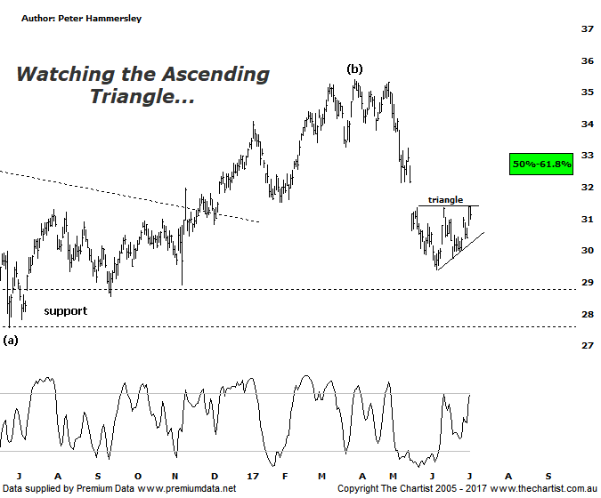

Bottom Line
5/7:
Daily Trend: Up
Weekly Trend: Down
Monthly Trend: Down
Support Levels: $29.40 / $27.57 - $26.92
Resistance Levels: $32.39 - $33.10 / $39.85
Video Analysis
Watch Video Analysis Here
Technical Discussion
Westpac is Australia’s oldest banking group which operates throughout Australia and New Zealand. It is divided into three core businesses: Australian Financial Services, Institutional and New Zealand. Other brands it operates are St George, Bank of Melbourne, BankSA, RAMS and BT Financial Group. The recent period of NZ bank earnings outperformance over Australia is now coming to an end. NZ is coming off a cyclical peak of bad debt reduction analysts suggest the challenges ahead appear to be manageable. For the year ending the 30th of September 2016 interest income decreased 1% to A$31.82B. Net interest income after loan loss provision increased 4% to A$14.02B. Net income applicable to shareholders decreased 7% to A$7.44B. Net interest income after loan loss provision highlights the consumer bank section increase of 13% to A$6.68B. The dividend yield is 6.0%. Broker consensus is currently “Hold”.
Reasons to be cautiously optimistic longer term (Caution short-term):
→ Good growth prospects compared to its peers.
→ Has defensive qualities and is not exposed significantly to volatility in mining or NZ dairy.
→ A low risk profile coupled with cost discipline.
→ High return on net tangible assets means its dividends face the least downside risk.
→ Defensively positioned loan book.
→ Banking sector valuations now considered at fair value.
→ Broken up through horizontal resistance.
Our last look at Westpac was via the monthly chart which showed there was still plenty of upside potential ahead over the much longer term, albeit a more significant retracement was likely to occur before a multi-year trend higher kicked in. Nothing has changed over the past few weeks despite the fact a rally has been unfolding. The problem with the banks is that impulsive price action to the downside has been taking hold since late April/early May which should not complete the larger corrective patterns. As such, we must be aligned to the fact that a bounce only is taking hold here, albeit there is still upside potential with the typical retracement zone sitting between $32.39 - $33.10. It would take a push above the latter to suggest a deeper retracement is going to be avoided although this is looking unlikely when assessing the patterns. I have also pencilled in a small ascending triangle which could be a significant pattern should price break to the downside. Should this be the way forward, then a smaller 5-wave movement will likely take price down toward the zone of support before the overdue bounce kicks in. Either way, any rally should be short-lived meaning caution is still required. The typical retracement zone as annotated will only be significant if price breaks through the upper trend line of the aforementioned triangle immediately. As we mentioned last time, if the banks are to embark on another leg South it’s going to have a negative effect on the broader market as it’s difficult to see other sectors propping the XJO up.
Trading Strategy
Even if the current bounce continues into the target area there isn’t enough in it to warrant jumping on with the risk/reward unacceptable. In fact, a corrective pattern higher into the typical retracement zone will present a shorting opportunity over the coming weeks. Timing must be spot-on with short setups, especially when stocks are looking oversold as this can often produce strong moves in the opposite direction due to short-covering. If you are waiting for the bigger buying opportunity in the banks it appears that plenty of patience is going to be required as the larger corrective patterns still need to complete.
Disclosure: Nick Radge holds

