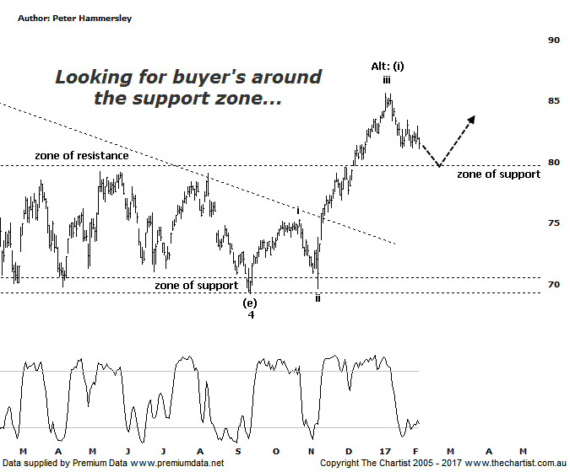

Bottom Line
7/2:
Daily Trend: Down
Weekly Trend: Up
Monthly Trend: Up
Support levels: $78.42 - $77.64 / $69.22
Resistance levels: $85.65 - $85.85 / $88.40
Video Analysis
Watch Video Analysis Here
Technical Discussion
Commonwealth Bank is Australia’s leading provider of integrated financial services including retail banking, premium banking, business banking, institutional banking, funds management, superannuation, insurance, investment and sharebroking products and services. The Group is one of the largest listed companies on the Australian Securities Exchange. It provides a full range of retail banking services including home loans, credit cards, personal loans, transaction accounts, and demand and term deposits through its Commonwealth Bank and Bankwest brands. The Group has leading domestic market shares in home loans, personal loans, retail deposits and discount stockbroking, and is one of Australia's largest credit card issuers. For the year ending the 30th of June 2016 interest income decreased 1% to A$33.82B. Net interest income after loan loss provision increased 6% to A$15.68B. Net income applicable to common shareholders increased 2% to A$9.18B. Broker/Analyst consensus is a comprehensive “Sell”. The dividend yield is currently 5.1%.
Reasons to be cautiously optimistic:
→ Regulatory fears eased.
→ Sold Visa shares which should improve capital ratios.
→ Trading at around an 8% premium to its peers with 14% being the average.
→ The quarterly update showed reduced bad debt and stronger market trading profits.
→ Improved discipline on mortgage pricing is required.
→ Healthy dividend over 5%.
The banking sector has had a decent run following the US election with the probable easing of capital requirements also helping sentiment. In fact, CBA shown here has rallied over 23% from the September low made last year which isn’t a bad effort all things considered. Not only that, but strong impulsive price action has returned which is something that has been absent for a significant period of time. At larger degree, our focus of attention has been on the descending triangle which is a pattern that normally crops up in the wave-4 position. This expectation also fits with prior price action. We are sticking to the daily timeframe this evening which shows the recent pivot high likely completes minor degree wave-iii. This means the current retracement is within wave-iv which looks set to continue over next week or two as a minimum. We’ve mentioned the guideline of alternation on a couple of occasions this week but it’s worth repeating as it’s pertinent to the patterns here. As can be seen wave-ii was very deep which means ideally wave-iv should be something completely different. That clearly isn’t the case with another leg down likely taking price back toward the minor zone of support. Should this be the way forward we’ll be looking for signs of strength returning pretty much immediately. If the zone of support gives way, then the alternate count comes to the fore which suggests intermediate degree wave-(i) is already in place. This would allow for a slightly deeper retracement with the typical retracement zone sitting at $77.64 - $75.75. This wouldn’t change the wave count a great deal but it would allow for the slightly deeper retracement. Either way, medium to longer-term the patterns have taken a turn for the better.
Trading Strategy
Today we were stopped out of our long positions in CBA & ANZ with the end result being small profits in both. Not the ideal situation although with the smaller degree patterns running out of steam it was time to take defensive action. As mentioned above, recent weakness hasn’t put a dent into the more bullish outlook. Indeed, it would take a break beneath the 61.8% retracement level of the prior leg higher sitting at $75.75 to suggest all is not well although ideally those lower levels won’t come under any serious pressure. For now we’ll monitor the “big four” but ideally an opportunity will present itself at lower levels.

Disclosure: Nick Radge holds

