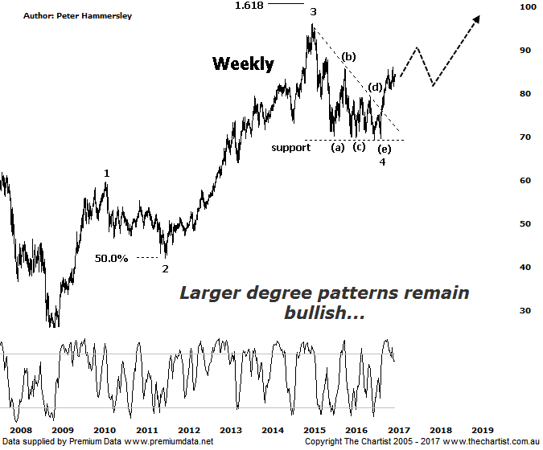

Bottom Line
14/3:
Daily Trend: Up
Weekly Trend: Up
Monthly Trend: Up
Support levels: $81.05 / $79.20 - $79.09
Resistance levels: $86.09 / $96.16
Video Analysis
Watch Video Analysis Here
Technical Discussion
Commonwealth Bank is Australia’s leading provider of integrated financial services including retail banking, premium banking, business banking, institutional banking, funds management, superannuation, insurance, investment and sharebroking products and services. The Group is one of the largest listed companies on the Australian Securities Exchange. It provides a full range of retail banking services including home loans, credit cards, personal loans, transaction accounts, and demand and term deposits through its Commonwealth Bank and Bankwest brands. The Group has leading domestic market shares in home loans, personal loans, retail deposits and discount stockbroking, and is one of Australia's largest credit card issuers. For the six months ending the 31st of December 2016 interest income decreased 1% to A$16.67B. Net interest income after loan loss provision increased 4% to A$8.14B. Net income applicable to shareholders increased 7% to A$4.9B. Net interest income after loan loss provision reflects the retail banking services section increase of 6% to A$4.23B. Broker/Analyst consensus is a comprehensive “Sell”. The dividend yield is currently 5.0%.
Reasons to be cautiously optimistic:
→ Regulatory fears eased.
→ Sold Visa shares which should improve capital ratios.
→ Trading at around an 8% premium to its peers with 14% being the average.
→ The quarterly update showed reduced bad debt and stronger market trading profits.
→ Improved discipline on mortgage pricing is required.
→ Healthy dividend around 5%.
It’s still quite difficult to find any broker that is bullish on the Banking Sector although having said that they aren’t particularly bearish either. This has been their stance for several months now and of course prices have been galloping higher. CBA has still advanced around 22% from the September 2016 lows which isn’t a bad effort. Not only that, but price action has been impulsive in nature for the most part which in itself is reason to sit up and take notice. We haven’t made secret of the fact that CBA has been our favourite of the big four over the past few years and there’s no reason to deviate from this stance. We are going to shift back to the weekly chart this evening though to remind ourselves of the larger degree patterns, especially as they retain a bullish look about them. From the 2009 lows a large 5-wave movement higher is unfolding with wave-4 unfolding as a triangle which is very common. Not only that, but the upper boundary of the structure has been overcome within a clean trend which keeps the door wide open for something much more bullish to unfold. As wave-3 was extended we’d expect wave-5 to be similar in length to wave-1 which provides a target up at $105.00 which is still a significant percentage gain from current levels. Should this transpire then blue sky territory is going to be attained over the coming months. The only caveat is that the patterns in the XJO, and even in most of the other banks aren’t looking quite so bullish. Still, CBA has led the way forward before and there’s no reason why it can’t do so again. It’s a heavyweight and it has plenty of clout.
Trading Strategy
Although we are concentrating on the weekly chart here we are going to take our trade setup from the daily timeframe. It appears that a smaller degree wave-iv is currently unfolding meaning a push up above the recent pivot high at $86.09 would be reason to jump on. Place the initial stop just beneath the prior pivot low which at this stage sits at $81.75 although this may change as the smaller degree patterns progress. As previously mentioned our target sits up at $105.00. We are going to make a formal recommendation this evening within the position status Page.

Disclosure: Nick Radge holds

