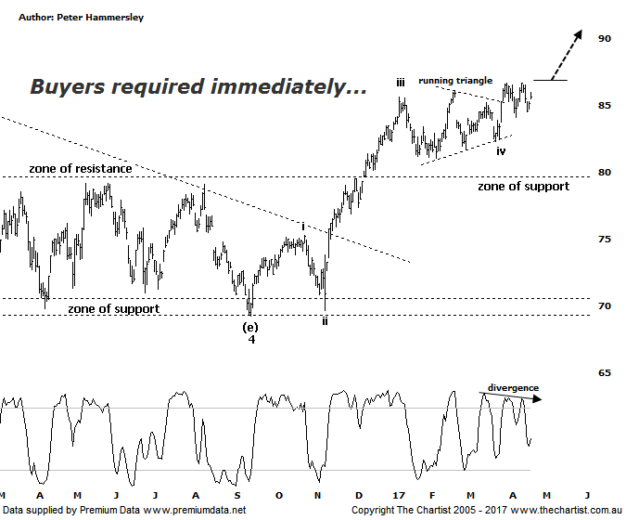

Bottom Line
21/4:
Daily Trend: Neutral
Weekly Trend: Up
Monthly Trend: Up
Support levels: $81.05 / $79.20 - $79.09
Resistance levels: $86.65 / $96.16 / $105.00
Video Analysis
Watch Video Analysis Here
Technical Discussion
Commonwealth Bank is Australia’s leading provider of integrated financial services including retail banking, premium banking, business banking, institutional banking, funds management, superannuation, insurance, investment and sharebroking products and services. The Group is one of the largest listed companies on the Australian Securities Exchange. It provides a full range of retail banking services including home loans, credit cards, personal loans, transaction accounts, and demand and term deposits through its Commonwealth Bank and Bankwest brands. The Group has leading domestic market shares in home loans, personal loans, retail deposits and discount stockbroking, and is one of Australia's largest credit card issuers. For the six months ending the 31st of December 2016 interest income decreased 1% to A$16.67B. Net interest income after loan loss provision increased 4% to A$8.14B. Net income applicable to shareholders increased 7% to A$4.9B. Net interest income after loan loss provision reflects the retail banking services section increase of 6% to A$4.23B. Broker/Analyst consensus is a comprehensive “Sell”. The dividend yield is currently 5.0%.
Reasons to be cautiously optimistic:
→ Regulatory fears eased.
→ Sold Visa shares which should improve capital ratios.
→ Trading at around an 8% premium to its peers with 14% being the average.
→ The quarterly update showed reduced bad debt and stronger market trading profits.
→ Improved discipline on mortgage pricing is required.
→ Healthy dividend around 5%.
We’ve been noting bearish divergence on the banks over the past few weeks although during our last review CBA was the only one of the big four not to have this headwind. This is no longer the case on the weekly chart with price making a higher high whilst our oscillator has failed to confirm by making a lower high. The positive is that it’s yet to trigger meaning it’s something to watch only as opposed to advocating a top being in position. We’ll continue to monitor over the coming weeks. In terms of our wave count nothing changes although this evening we are going to flip back to the daily timeframe. Larger degree wave-4 terminated around the zone of support circa $70.00 from where strong impulsive price action has taken hold. A sideways consolidation has been transpiring since the beginning of the year which has taken the form of a running Triangle. I’ll discuss further during the video. One thing to always remember with Elliott Wave is that a triangle is usually the penultimate move within a 5-wave structure. In other words, it usually crops up during the wave-iv position which is exactly the situation here. If the wave count is to continue to prove itself then buyers need to step up immediately as further posturing in this area would suggest an interim top is already in place. Today was much better for the banks and therefore the market in general though the question now is whether strength can continue. Much is going to depend on the divergence mentioned above.
Trading Strategy
“…Although we are concentrating on the weekly chart here we are going to take our trade setup from the daily timeframe. It appears that a smaller degree wave-iv is currently unfolding meaning a push up above the recent pivot high at $86.09 would be reason to jump on. Place the initial stop just beneath the prior pivot low which at this stage sits at $81.75…” We are now holding long positions with price hovering around breakeven since entry. Perhaps not ideal although it shouldn’t come as a great surprise considering the broader market has been in consolidation mode. If you aren’t already involved it’s best to remain sidelined although bigger picture we still believe our target up around $105.00 can be achieved over the longer term.

Disclosure: Nick Radge holds

