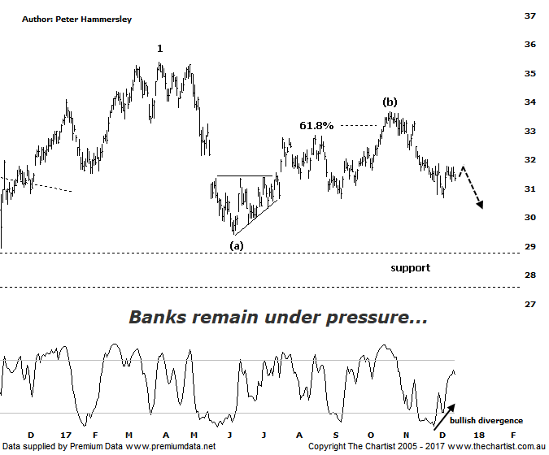

Bottom Line
15/12:
Daily Trend: Up
Weekly Trend: Down
Monthly Trend: Down
Support Levels: $29.40 / $27.57
Resistance Levels: $34.01 / $35.39
Video Analysis
Watch Video Analysis Here
Technical Discussion
Westpac is Australia’s oldest banking group which operates throughout Australia and New Zealand. It is divided into three core businesses: Australian Financial Services, Institutional and New Zealand. Other brands it operates are St George, Bank of Melbourne, BankSA, RAMS and BT Financial Group. The recent period of NZ bank earnings outperformance over Australia is now coming to an end. NZ is coming off a cyclical peak of bad debt reduction analysts suggest the challenges ahead appear to be manageable. For the year ending the 30th of September 2017 interest income decreased 2% to A$31.23B. Net interest income after loan loss provision increased 5% to A$14.66B. Net income applicable to shareholders increased 7% to A$7.98B. Net interest income after loan loss provision reflects the Consumer Bank section increase of 4% to A$6.97B. The dividend yield is 6.0%. Broker consensus is currently “Hold”.
Reasons to be cautiously optimistic longer term (Caution short-term):
→ Continues to do well in transaction banking.
→ Good growth prospects compared to its peers.
→ Has defensive qualities and is not exposed significantly to volatility in mining or NZ dairy.
→ A low risk profile coupled with cost discipline.
→ High return on net tangible assets means its dividends face the least downside risk.
→ Defensively positioned loan book.
→ Banking sector valuations now considered at fair value.
→ Broken up through horizontal resistance.
The banks have been suffering over the past few weeks with the various announcements triggering further falls. Last time we were asking the question as to whether a larger consolidation pattern was going to unfold which was basis the 61.8% retracement level of the prior leg down being overcome by a reasonable margin. Whenever the typical retracement zone is overcome there’s a good chance that a shallower correction, perhaps a flat pattern or a triangle is going to unfold which is still feasible here. However, the leg down from the high of wave-(b) is starting to look impulsive in nature and if this continues, the zone of support is likely going to come under pressure over the coming weeks. The worst-case scenario is that price heads down to the wave equality projection at $27.69 although if this transpires then the more typical zigzag is going to be the correction of choice. As we’ve been saying over the past few months, we haven’t been keen on the banking sector over the short to medium term and our stance hasn’t changed. That said, continued choppy and messy price action isn’t going to be the end of the world, and bigger picture we continue to expect substantially higher prices, albeit further down the track. For now though, the risk is to the downside with decent trends hard to come by, both to the up and to the downside. The only good news on the chart is Type-A bullish divergence which has likely been the reason for the recent rally. Our oscillator is now within touching distance of the overbought position meaning it shouldn’t be a tailwind for too much longer. Either way, we are sceptical of the recent bounce being sustainable.
Trading Strategy
One of the main problems for the broader market is that the banking sector has a weighting of around 30%. This has been our concern for the XJO, as without the banks participating it’s going to be extremely difficult to gain any sort of traction. This is one of the reasons why the smaller cap stocks, evidenced by the (XSO) has been outperforming recently. If we are correct with our analysis here, then the smaller end of town is probably going to outperform for the foreseeable future. One thing is for sure, we don’t want to be involved with Westpac from a trading perspective at this stage.
Disclosure: Trish Radge holds

