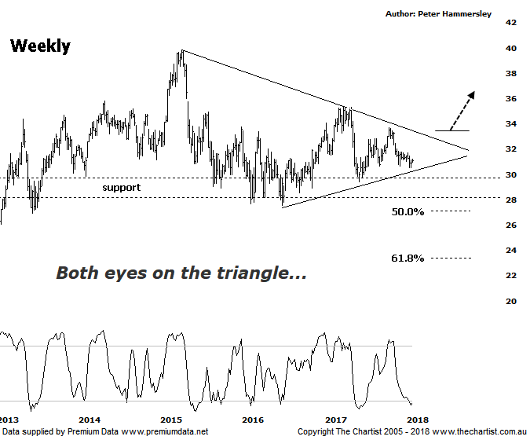

Bottom Line
29/12:
Daily Trend: Up
Weekly Trend: Down
Monthly Trend: Down
Support Levels: $29.40 / $27.57
Resistance Levels: $34.01 / $35.39
Video Analysis
Watch Video Analysis Here
Technical Discussion
Westpac is Australia’s oldest banking group which operates throughout Australia and New Zealand. It is divided into three core businesses: Australian Financial Services, Institutional and New Zealand. Other brands it operates are St George, Bank of Melbourne, BankSA, RAMS and BT Financial Group. The recent period of NZ bank earnings outperformance over Australia is now coming to an end. NZ is coming off a cyclical peak of bad debt reduction analysts suggest the challenges ahead appear to be manageable. For the year ending the 30th of September 2017 interest income decreased 2% to A$31.23B. Net interest income after loan loss provision increased 5% to A$14.66B. Net income applicable to shareholders increased 7% to A$7.98B. Net interest income after loan loss provision reflects the Consumer Bank section increase of 4% to A$6.97B. The dividend yield is 6.0%. Broker consensus is currently “Hold”.
Reasons to be cautiously optimistic longer term (Caution short-term):
→ Continues to do well in transaction banking.
→ Good growth prospects compared to its peers.
→ Has defensive qualities and is not exposed significantly to volatility in mining or NZ dairy.
→ A low risk profile coupled with cost discipline.
→ High return on net tangible assets means its dividends face the least downside risk.
→ Defensively positioned loan book.
→ Banking sector valuations now considered at fair value.
→ Broken up through horizontal resistance.
One thing is certain, we haven't been bullish on the banks for what seems like an eternity now although this evening we are going to take a step back and look at the weekly chart which offers some hope. Before we do though, it’s worth reiterating that the wave count put forward here would be deemed an “alternate count” and still needs to prove itself. Although it’s not a textbook symmetrical triangle the basic shape is apparent, and as such we must give it some respect. In fact, a very similar pattern formed between November 2007 and August 2011, although this again wasn’t a textbook triangle. However, it proved to be significant and we must be open to the possibility that this one has the potential to provide the same result. From an Elliott stance the required 5-internal swings are in place meaning an inflection point is now upon us. Should the long-drawn-out consolidation pattern break to the upside, this would be a very bullish turn of events although for now we need to keep our feet firmly on the ground. There is still plenty of work to be done before heading up through the upper trend line, so we can’t quite start blowing the party balloons up yet. The contrarian in us also keeps the door open for something more bullish to unfold over the coming months, especially as it’s difficult to find any brokers or analysts that are positive the banks. Don’t get me wrong, we are not advocating a strong impulsive leg higher in the big four banks right here and now although a continuation pattern is in place and it deserves some recognition. A comprehensive break up through $34.00 would be a step in the right direction although what the trigger for such a move is going to be is anyone’s guess. However, the market has a habit of proving the herd wrong so perhaps this is going to be one of those times.
Trading Strategy
Despite the possibility of an upside break over the coming months it’s still not time to be jumping on, with price having to prove itself as mentioned above. If you are looking at the longer-term then keep an eye on the upper trend line of the triangle as once this is penetrated a big hurdle will have been overcome. For now though, it’s still better to stand aside as we believe there are better opportunities over the short to medium term in other sectors, especially the Materials sector.
Disclosure: Trish Radge holds

