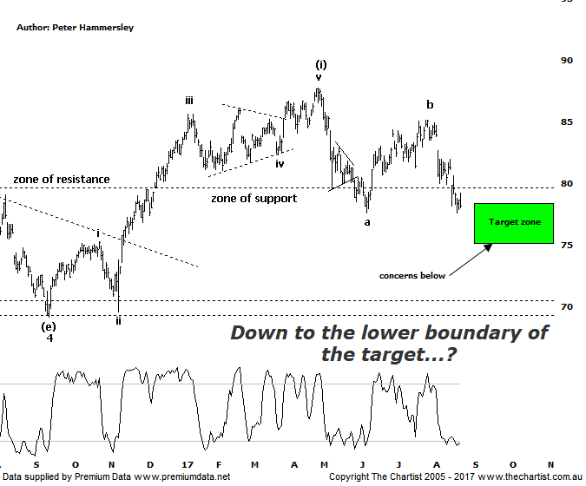

Bottom Line
23/8:
Daily Trend: Down
Weekly Trend: Down
Monthly Trend: Down
Support levels: $77.65 - $76.29 / $69.22
Resistance levels: $87.74 / $96.16 / $105.00
Video Analysis
Watch Video Analysis Here
Technical Discussion
Commonwealth Bank is Australia’s leading provider of integrated financial services including retail banking, premium banking, business banking, institutional banking, funds management, superannuation, insurance, investment and sharebroking products and services. The Group is one of the largest listed companies on the Australian Securities Exchange. It provides a full range of retail banking services including home loans, credit cards, personal loans, transaction accounts, and demand and term deposits through its Commonwealth Bank and Bankwest brands. The Group has leading domestic market shares in home loans, personal loans, retail deposits and discount stockbroking, and is one of Australia's largest credit card issuers. For the year ending the 30th of June 2017 interest income decreased 2% to A$33.29B. Net interest income after loan loss provision increased 5% to A$16.51B. Net income applicable to common stockholders increased 8% to A$9.93B. Net interest income after loan loss provision reflects Retail Banking Services section increase of 6% to A$8.53B. Broker/Analyst consensus is a comprehensive “Sell”. The dividend yield is currently 5.5%.
Reasons to be cautiously optimistic (short term weakness likely):
→ Yesterday’s announcement by APRA was less severe than originally anticipated.
→ Major banks should be able to offset the negative impact from the government levy by around 50%.
→ Regulatory fears eased.
→ Sold Visa shares which should improve capital ratios.
→ Trading at around an 8% premium to its peers with 14% being the average.
→ The recent update showed reduced bad debt and stronger market trading profits.
→ Improved discipline on mortgage pricing is required.
→ Healthy dividend over 5%.
There was no reason to be overly optimistic over the short-term during our last review with another leg lower likely needing to be seen to complete a larger corrective pattern. In fact, sellers stepped in immediately with the end result being weakness over the past few weeks taking price into the target area as shown. I have amended our target zone slightly because of the wave equality projection which is what makes up the lower boundary at $75.03. The deeper pull-back is a result of wave-a itself already tagging the 50% retracement level. The problem with this is that the further price gets down through the 61.8% retracement level, which in this case sits a $76.29, the greater the chance that something a little more bearish is going to unfold. In other words, buyers will need to step up to the plate at the lower boundary of the target zone otherwise our wave count is likely going to be invalidated. The patterns here are slightly different to those in ANZ with the latter looking to retrace a little deeper before the next bigger buying opportunity presents itself. The bearish divergence we’ve highlighted over the past few months on the big four banks has now unwound and there’s even Type-B bullish divergence showing on the weekly chart of CBA here which could potentially turn into the more potent Type-A variant. That said, it still needs to prove itself so I wouldn’t be getting overly optimistic on the back of it as it stands right here and now. As long as the bearish divergence doesn’t trigger immediately, we’ll retain a bearish stance over the short-term. Bigger picture this is the only bank that can still make a larger degree 5-wave movement higher from the January 2009 lows which just reiterates why it’s been our favoured bank over the past few years.
Trading Strategy
We are not currently involved in any of the banks although we do have a short set-up waiting to trigger in the position status page for ANZ. That trade is for the more aggressive amongst you and for those waiting for the bigger buying opportunity there is still no reason to be looking for an entry at this stage. As mentioned above, CBA is still our favourite of the big four although if we are to get a decent leg higher any time soon then buyers need to step up around the $75.00 region over the coming weeks. Either way, for the moment we’ll continue to sit this one out.

Disclosure: Nick Radge holds

