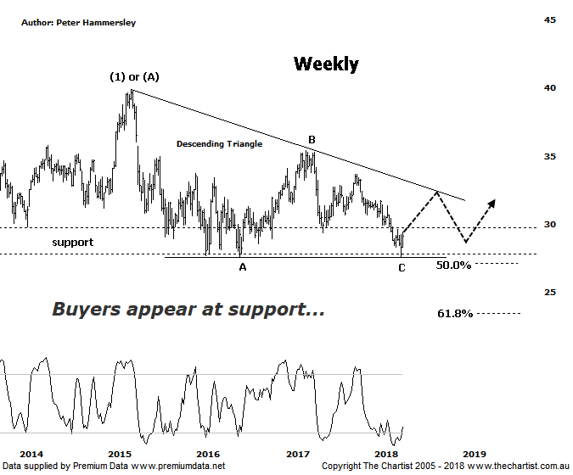

Bottom Line
4/5:
Daily Trend: Up
Weekly Trend: Down
Monthly Trend: Down
Support Levels: $27.57
Resistance Levels: $33.68 / $35.39
Video Analysis
Watch Video Analysis Here
Technical Discussion
Westpac is Australia’s oldest banking group which operates throughout Australia and New Zealand. It is divided into three core businesses: Australian Financial Services, Institutional and New Zealand. Other brands it operates are St George, Bank of Melbourne, BankSA, RAMS and BT Financial Group. The recent period of NZ bank earnings out performance over Australia is now coming to an end. NZ is coming off a cyclical peak of bad debt reduction analysts suggest the challenges ahead appear to be manageable. For the year ending the 30th of September 2017 interest income decreased 2% to A$31.23B. Net interest income after loan loss provision increased 5% to A$14.66B. Net income applicable to shareholders increased 7% to A$7.98B. Net interest income after loan loss provision reflects the Consumer Bank section increase of 4% to A$6.97B. The dividend yield is 6.2%. Broker consensus is currently “Hold”.
Reasons to be cautiously optimistic longer term (Caution short-term):
→ Continues to do well in transaction banking.
→ Good growth prospects compared to its peers.
→ Has defensive qualities and is not exposed significantly to volatility in mining or NZ dairy.
→ A low risk profile coupled with cost discipline.
→ High return on net tangible assets means its dividends face the least downside risk.
→ Defensively positioned loan book.
→ Banking sector valuations now considered at fair value.
→ Broken up through horizontal resistance.
We’ve been watching some large consolidation patterns in the big four banks over the past few months although several of those patterns have invalidated which takes away the prospect of seeing an impulsive leg higher any time soon. However, the descending triangle here remains in place with wave-C hitting the lower boundary last week which brought out a few buyers. Also note that the recent low coincides with lower boundary of the zone of support which has triggered demand several times over the past few years. What we can’t see on this weekly chart is that bullish divergence triggered last week on the daily time frame which is likely the reason for recent strength. However, our oscillator has already hit the overbought position meaning it’s no longer providing a tailwind. That’s not to say strength is going to dissipate, as this isn’t our highest expectation without first seeing higher prices. Should the large triangle continue to unfold in textbook form the next port of call should be the upper boundary which could offer a multi-week trend that will likely just fall short of the $32.00 region. Should this transpire then one final probe down would be expected as ideally we like to see 5-internal swings within these types of structures. Either way, buyers should step up around the zone of support, limiting downside. Bigger picture the upper boundary of the triangle will need to be overcome in an impulsive fashion before getting overly confident although even if a larger corrective pattern higher is going to unfold there is exceptional upside potential ahead. For the moment though, the banks are out of favour due to concerns regarding growth moving forward and the headwind of the Royal commission although news is expected around September which could be interesting.
Trading Strategy
Although the door is open to see a decent rally there isn’t enough in it to warrant making a formal recommendation. If you are a short-term swing trader, then look to jump on and take profits around the upper boundary of the triangle or at least tighten the protective stop as price approaches the trend line. Longer term traders and investors are better continuing to stand aside and letting the descending triangle conclude although this should be several months down the track.
Disclosure: Trish Radge holds

