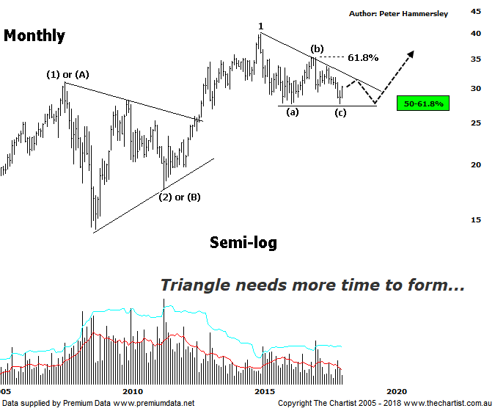

Bottom Line
16/5:
Daily Trend: Up
Weekly Trend: Up
Monthly Trend: Down
Support Levels: $27.57
Resistance Levels: $33.68 / $35.39
Video Analysis
Watch Video Analysis Here
Technical Discussion
Westpac is Australia’s oldest banking group which operates throughout Australia and New Zealand. It is divided into three core businesses: Australian Financial Services, Institutional and New Zealand. Other brands it operates are St George, Bank of Melbourne, BankSA, RAMS and BT Financial Group. The recent period of NZ bank earnings out performance over Australia is now coming to an end. NZ is coming off a cyclical peak of bad debt reduction analysts suggest the challenges ahead appear to be manageable. For the year ending the 30th of September 2017 interest income decreased 2% to A$31.23B. Net interest income after loan loss provision increased 5% to A$14.66B. Net income applicable to shareholders increased 7% to A$7.98B. Net interest income after loan loss provision reflects the Consumer Bank section increase of 4% to A$6.97B. The dividend yield is 6.3%. Broker consensus is currently “Hold”.
Reasons to be cautiously optimistic longer term (Caution short-term):
→ Continues to do well in transaction banking.
→ Good growth prospects compared to its peers.
→ Has defensive qualities and is not exposed significantly to volatility in mining or NZ dairy.
→ A low risk profile coupled with cost discipline.
→ High return on net tangible assets means its dividends face the least downside risk.
→ Defensively positioned loan book.
→ Banking sector valuations now considered at fair value.
→ Broken up through horizontal resistance.
It’s no secret that we haven’t been big fans of the banks this year although bigger picture there is reason to be more optimistic. In fact, on this monthly chart nothing changes from a year ago. Back then, price had just tagged and rejected from the 61.8% retracement level strongly suggesting that a significant top was locked in. As such, we were looking for a substantial retracement, taking price into the typical retracement zone as annotated. In that regard, we couldn’t have asked for anything more with weakness continuing over the past 12 months. The typical retracement zone of the prior leg higher out of the symmetrical triangle has now been tagged meaning theoretically we have entered a reversal zone. However, as mentioned on the weekly chart last time, a descending triangle could be unfolding which means more time is going to be required before the breakout transpires. The reason being, an Elliott triangle needs to contain 5-internal swings labelled (a) through-(e) which is a requirement that has yet to be met. In fact, the recent pivot low should complete wave-(c) with recent strength likely taking price up to the upper boundary of the pattern which offers reasonable upside over the coming weeks. This should be followed by one final probe lower which should set the stage for the next significant leg higher. In other words, the patterns still need to prove themselves although at this juncture that’s precisely what they are doing. However, it does mean that more time is required (several months) before the attempted breakout transpires. With the typical retracement zone already tagged it’s important that the lower boundary at $26.12 isn’t overcome. If it is, then our wave count starts to come under pressure which would put a big dent into the longer-term bullish case. Fundamentally, the banks do have headwinds, with growth being an obvious talking point although this is already likely factored into price. The Royal Commission is also causing uncertainty although information is expected in September which could provide some clarity.
Trading Strategy
I’ll be looking at the chart of the Banking sector (XXJ) tomorrow although it shows a similar picture to the one shown here. As mentioned during our last review, there is upside potential over the coming weeks although there is not enough in it to warrant being involved from a trading perspective. We’ll happily remain sidelined and concentrate on other sectors whilst the current corrective pattern runs its course which as mentioned should be several months down the track.
Disclosure: Trish Radge holds

