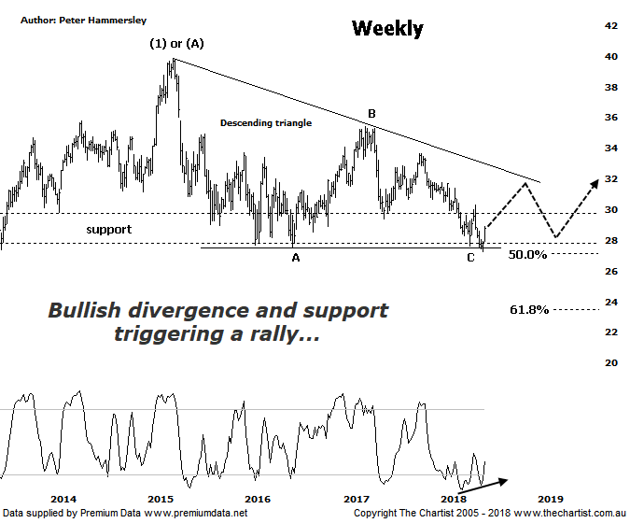

Bottom Line
20/6:
Daily Trend: Up
Weekly Trend: Down
Monthly Trend: Down
Support Levels: $27.24
Resistance Levels: $33.68 / $35.39
Video Analysis
Watch Video Analysis Here
Technical Discussion
Westpac is Australia’s oldest banking group which operates throughout Australia and New Zealand. It is divided into three core businesses: Australian Financial Services, Institutional and New Zealand. Other brands it operates are St George, Bank of Melbourne, BankSA, RAMS and BT Financial Group. The recent period of NZ bank earnings out performance over Australia is now coming to an end. NZ is coming off a cyclical peak of bad debt reduction analysts suggest the challenges ahead appear to be manageable. For the year ending the 30th of September 2017 interest income decreased 2% to A$31.23B. Net interest income after loan loss provision increased 5% to A$14.66B. Net income applicable to shareholders increased 7% to A$7.98B. Net interest income after loan loss provision reflects the Consumer Bank section increase of 4% to A$6.97B. The dividend yield is 6.7%. Broker consensus is currently “Hold”.
Reasons to be cautiously optimistic longer term (Caution short-term):
→ Continues to do well in transaction banking.
→ Good growth prospects compared to its peers.
→ Has defensive qualities and is not exposed significantly to volatility in mining or NZ dairy.
→ A low risk profile coupled with cost discipline.
→ High return on net tangible assets means its dividends face the least downside risk.
→ Defensively positioned loan book.
→ Banking sector valuations now considered at fair value.
→ Broken up through horizontal resistance.
Our last look at Westpac was during Big picture week where we concentrated on the monthly chart. This showed a large descending triangle which bigger picture is a bullish proposition. This weekly chart also concentrates on the triangle and although the prior pivot low has been overcome by a small margin, buyers have once again stepped up to the plate around what essentially is horizontal support. This is positive and sets the stage for the next leg higher. That said, if we are to see our required 5-internal swings within an Elliott triangle the upper trend line of the pattern should be the full extent of any rally although this is still a reasonable percentage gain from current levels. Adding weight to the case for higher prices is bullish divergence with price making a lower low whilst our oscillator has failed to confirm by making a higher low. This is in stark contrast to many companies we’ve been review recently which are showing bearish divergence on these weekly timeframes. Should the patterns play out as anticipated price should reject from diagonal resistance and come back down toward the zone of support although remember we are looking at the weekly timeframe here meaning it’s likely going to take several months for the pattern to run its full course. At this juncture there appears to be some light at the end of the tunnel for the banks although it’s still early days regarding the larger degree patterns and we must remain cautious for the time being. One thing is for sure, a push down through the low made a week ago at $27.24 in a move that sticks would be reason for concern as it would invalidate the triangle and set the stage for a more conventional zigzag to take price toward the lower boundary of the typical retracement zone as a minimum. The wave equality projection sits down at $23.11 and would also be feasible. This is just something to bear in mind should the patterns deteriorate and is by no means a high probability target. The triangle remains headline pattern.
Trading Strategy
“…I’ll be looking at the chart of the Banking sector (XXJ) tomorrow although it shows a similar picture to the one shown here. As mentioned during our last review, there is upside potential over the coming weeks although there is not enough in it to warrant being involved…” Nothing changes in that there is still upside potential over the coming weeks despite price revisiting the lower boundary of the zone of support again recently. The question now is whether current strength is a Dead cat bounce which is going to fade as quickly as it started or the start of a reasonable trend. We favour the latter although as implied above we can’t quite blow the party balloons up yet. If you want to be involved you could jump on right here and now and place the protective stop just beneath the prior pivot low at $27.23 which provides a low risk entry. Look to take profits around the upper boundary of the descending triangle or at least tighten the protective stop at those higher levels. There is no formal recommendation although the banks are back on the watchlist.
Disclosure: Trish Radge holds

